BOX OFFICE MANUAL
~2026~

VENUE INFORMATION 2
MELBOURNE RECITAL CENTER (MRC) 5
MCEC THE PLENARY 7
Sidney Myer Music Bowl (SMMB) 7
Hamer Hall 7
Melbourne Town Hall 7
Melbourne Recital Centre (MRC) 7
Iwaki Auditorium 7
Robert Blackwood Hall 7
MCEC Plenary 7
Sidney Myer Music Bowl 7
CUSTOMER AND PRODUCT OVERVIEW 7
First Look Seats 7
Programs 7
Price Types 7
Concession Card Details 7
Subscribers and Subscriptions 7
Child Price Subscriptions 7
School Bookings 7
School Booking Request Form 7
Geelong School Booking Request Form 7
Ticket delivery 7
Composing Australia 7
Jams for Juniors 7
Classic Kids and Classic Kids Relaxed 7
Under 18/Child Price Tickets and Babes-In-Arms Policy 7
MEMBERSHIPS 7
Adding eMemberships to a Constituency 7
Friends of the MSO Members (FOTMSO) | Memberships 7
Friends of the MSO Members (FOTMSO) | Creating & Sending Membership Pack 7
Student Memberships 7
Tickets to free events (Open Rehearsals, Cybec etc) - 2 tickets per member 7
Gold Membership - Gala event B Reserve ticket - upgrade at cost 7
Staff Tickets 7
Comps 7
Staff Ticket Exchanges 7
TICKET CHANGES 7
Exchange Ticket Price Explainer 7
Change of Mind 7
Exchange FAQ's & Cheat Sheet 7
General Venue Exchanges 7
Geelong Arts Centre Exchanges 7
West Gippsland and Frankston Arts Centre Exchanges 7
Credit Requests / Medical Certificate 7
Price Difference 7
Refunds 7
Ticket Resale (Tixel) 7
Payments 7
Instalment Plans 7
Instalment Plans - Payment Errors/Failures 7
Donations/ Contributions 7
Refund to Cancelled Card (ARN). 7
Instalment Payment Date Calculator 7
Refund by Bank Transfer 7
Gift Card 7
MSO Gift Cards 7
FOTMSO Gift Card 7
Refund to Gift Card 7
Benefits and Discounts 7
MSORACV - RACV Member Discount (Updated) 7
Mob Tix 2026 7
MYOMEMBER - MYO Member Discount 7
MSOPARTNER - 2025 Corporate Partner Discount 7
Bring a Friend - 2025 FOTMSO Membership Benefit 7
MSOSHARE - Industry Offers 7
Emirates 7
Partner Discounts 7
PARTNERS - GENERAL 7
ARTS VENUES 7
Mob Tix 7
Rush Tickets 7
Bonus Concerts 7
CSIs with a Performance/Package 7
Calendly 7
First Nations Feedback Response 7
CSI Formatting Rules (Regular CSIs) 7
SCRIPTS TO END CALLS 7
Access Bookings 7
Feedback and Complaints 7
Difficult Customers - Calls & In Person 7
Web Login (inc. Issues/Troubleshooting) 7
PROCEDURES 7
Donating Tickets 7
Geelong Subscriber Forms 7
Merch Orders 7
Return to Sender 7
Instructions for Mail Merge/Brochure Request 7
Deceased Constituents 7
Deceased Estate Policy 7
Accessibility Special Requests email report 7
HowScan Procedure 7
School Bookings procedure 7
School Bookings Tracker 7
School Booking Request Form 7
Geelong School Booking Request Form 7
School Excursion Documents 7
Batch Printing Tickets 7
Batch Print for Postage 7
Venue Collection 7
Relocates Process 7
Releasing Subscription 7
Open CSI Report 7
Manually Processing Instalment Payments 7
Hold Until Report 7
POLICIES 7
Instalment Plan Grace Period - Purchasing in July 7
Concessions 7
Group Bookings 7
Phone safety protocol 7
High risk situations 7
EMAIL TEMPLATES 7
OTHER 7
Digital Tickets 7
Tickets as gifts 7
Tessi VS16 7
IDEAS / THINGS TO ADD 7
Refresher Training 7
EXCHANGES: 7
Different Types of Hold Codes, what they mean, and can they be used?? 7

VENUE INFORMATION
Melbourne Town Hall (MTH)
Location: 90/130 Swanston St, Melbourne VIC 3000
Performances: Town Hall Series (TH[year]) and some Special and Commercial Events
The Front of House (ushering/cloak room) is run by Arts Centre Melbourne (ACM), but they do not provide any ticketing. Front doors open 90 minutes prior to performance, and auditorium doors open 30 minutes prior to performance.
What needs to be brought to Town Hall venue shifts?
2 x Laptops (LT bags include mouse, charger etc), Banners (as specified in concert sheet), 2 x EFTPOS machine, Wifi box, 2 x Power Board, Extension Cord, Gaffe tape, Ticket Stock, 5 x Season Brochures, Lost Ticket Book, Stationary (Pens, notebook, scissors, blue-tack, sticky tape), BO Open Signage, Confidential Waste Folder, BOCA printer, QR Code Signage, Crocodile (Ticker Sorter), Black Tablecloth.
A free organ recital (6:30pm) for ticketholders occurs prior to most Town Hall performances.
A map of Town Hall is available here.
More information on Town Hall is available here.
Lost Property Contact: 03 9658 9658
HAMER HALL (HH)
Location: Arts Centre Melbourne, 100 St Kilda Road, Southbank 3004
Performances: Majority of MSO concerts (e.g. Core Classical, Thurs Night, Sat Matinee, Mornings, Special and Commercial Events, Season Galas, etc.)
The space is run by Arts Centre Melbourne (ACM), who also sell tickets to our performances here. Their number is 1800 183 183 and email is ticketing@artscentremelbourne.com.au.
Front doors open 90 minutes prior to performance, and auditorium doors open 30 minutes prior to performance.
A map of Hamer Hall is available here.
More information on Hamer Hall is available here.
Information on Swing Arm Seating is available here.
General Venue FAQS:
Where is the Cloakroom?
The Cloakroom is located in Level 6 (St Kilda Road entry level) and around to the left hand side as you enter, past the ACM Bar with hot food.
Where is the Viewing Room?
The Viewing Room is located on Level 4 - same as Door 5-6 for Circle. This is a soundproofed room that can be utilised by latecomers or for patrons who may need to watch the concert in a more discreet manner (ongoing cough, baby crying, etc)
What is the easiest way to access Hamer Hall from the ACM car park?
Via the Theatres Building. Pedestrian access is also available via the stairwell located between the Arts Centre forecourt and the National Gallery of Victoria moat. Car park access for people who cannot use stairs is via Southbank Boulevard. From the carpark, it is a approx. 5 min walk to Hamer Hall down St Kilda Rd towards the Yarra River.
Customers should call ACM Box Office on 1300 182 183 for more detailed queries.
Where else can I park for Hamer Hall?
- The Primrose Potter Australian Ballet Centre Car Park* (via Kavanagh Street)
- Wilson Parking Southgate Car Park (via City Road)
- Wilson Parking Eureka Car Park (via City Road)
*Please note there is a lift in the Ballet Centre Foyer that leads to a covered walkway across to St Kilda Road.

Lost property contact details: (03) 9281 8316,

MELBOURNE RECITAL CENTER (MRC)
Location: Elisabeth Murdoch Hall, 31 Sturt St, Southbank VIC 3006
Performances: Recital Centre Series (RC[year])
The space is run by Melbourne Recital Centre (MRC) who also sell tickets to our performances here. Front doors open 90 minutes prior to performance, and auditorium doors open 30 minutes prior to performance.
What needs to be brought to Recital Centre venue shifts?
2 x Laptops (LT bags include mouse, charger etc), Banners (as specified in concert sheet), 2 x EFTPOS machine, Wifi box, 2 x Power Board, Extension Cord, Gaffe tape, Ticket Stock, 5 x Season Brochures, Lost Ticket Book, Stationary (Pens, notebook, scissors, blue-tack, sticky tape), BO Open Signage, Confidential Waste Folder, BOCA printer, QR Code Signage, Crocodile (Ticker Sorter), Black Tablecloth.
(There are pre-concert talks at 6:45pm for the Recital Centre Series)
A map of MRC is available here.
More information on MRC is available here.
A reminder that wheelchair seats at MRC don't contain an actual seat. These seats are for customers remaining in their wheelchair.
Lost property contact: +61 (0)3 9699 2228

IWAKI AUDITORIUM
Location: ABC Building Level 1, 120 Southbank Blvd (Cnr of Moore St), Southbank, 3006
Performances: Chamber Series (CP[year]), Jams for Juniors, Music & Ideas
The space is run by ABC Building who provide security - with one guard stationed at entry doors and a second guard providing swipe access to bathrooms. Iwaki performances are exclusively ticketed by MSO.
Front doors open approximately 60 minutes prior to performance, and auditorium doors open 15-20 minutes prior to performance.
What needs to be brought in the road case to Iwaki Auditorium for Jams for Juniors performances?
2 x Laptops (LT bags include mouse, charger etc), Banners (as specified in concert sheet), 2 x EFTPOS machine, Wifi box, 2 x Power Board, Extension Cord, Gaffe tape, Black Tablecloth, Ticket Stock, 5 x Season Brochures, Lost Ticket Book, Stationary (Pens, notebook, scissors, blue-tak, sticky tape), BO Open Signage, Confidential Waste Folder, Seating Book, 2 x iPads.
What needs to be brought in the road case to Iwaki Auditorium for other performances?
2 x Laptops (LT bags include mouse, charger etc), Banners (as specified in concert sheet), 2 x EFTPOS machine, Wifi box, 2 x Power Board, Extension Cord, Gaffe tape, Black Tablecloth, Ticket Stock, 5 x Season Brochures, Lost Ticket Book, Stationary (Pens, notebook, scissors, blue-tak, sticky tape), BO Open Signage, Confidential Waste Folder, Seating Book, 2 x iPads, BOCA printer, QR Code Signage, Crocodile (Ticker Sorter).

Iwaki is a general admission venue - no seat map available.
More information on Iwaki is available here.

For lost property queries, please contact vic.property@abc.net.au and log here

MCEC THE PLENARY
Location: Melb. Convention & Exhibition Centre, 1 Convention Centre Pl, South Wharf VIC 3006
Performances: Special Events. E.g. MSO at the Movies
The space is run by Melbourne Convention & Exhibition Centre (MCEC). MSO exclusively tickets these events. Venue is accessible to the public during daytime hours, and auditorium doors open 30 minutes prior to performance.
What needs to be brought to Plenary venue shifts?
2 x Laptops (LT bags include mouse, charger etc), Banners (as specified in concert sheet), 2 x EFTPOS machine, Wifi box, 2 x Power Board, Extension Cord, Gaffe tape, Ticket Stock, 5 x Season Brochures, Lost Ticket Book, Stationary (Pens, notebook, scissors, blue-tack, sticky tape), BO Open Signage, Confidential Waste Folder, BOCA printer, QR Code Signage, Crocodile (Ticker Sorter).
A map of The Plenary is available here.
An interactive map can be found here.
More information on The Plenary is available here.
Lost property contact: +61 3 9235 8000
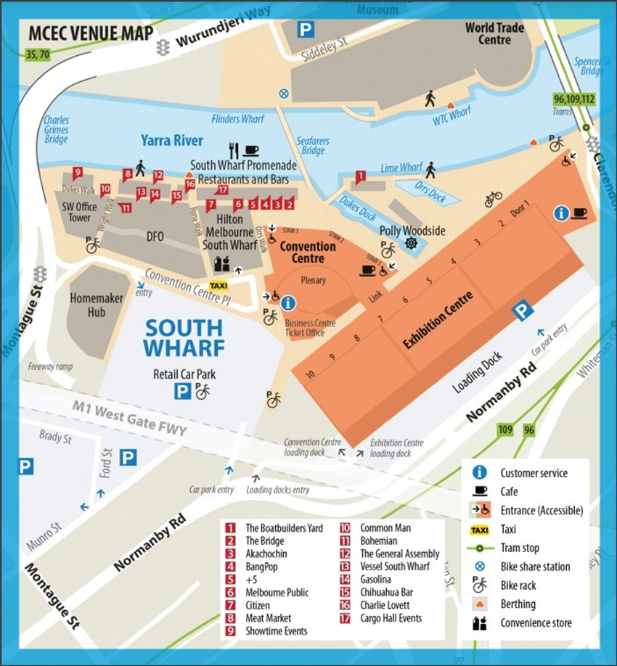
Robert Blackwood Hall (RBH)
Location: 49 Scenic Blvd, Clayton VIC 3168 (Monash University, Clayton Campus)
Performances: Previously the home of the Monash Series, now a venue for sporadic concerts in the South-East of Melbourne

The space is run by Monash University, who also sell tickets to our performances here. Front doors open 90 minutes prior to performance, and auditorium doors open 30 minutes prior to performance.

What needs to be brought to Robert Blackwood Hall venue shifts?
2 x Laptops (LT bags include mouse, charger etc), Banners (as specified in concert sheet), 2 x EFTPOS machine, Wifi box, 2 x Power Board, Extension Cord, Gaffe tape, Ticket Stock, 5 x Season Brochures, Lost Ticket Book, Stationary (Pens, notebook, scissors, blue-tack, sticky tape), BO Open Signage, Confidential Waste Folder, BOCA printer, QR Code Signage, Crocodile (Ticker Sorter).

A map of Robert Blackwood Hall is available here.
More information on Robert Blackwood Hall is available here.

Lost property contact: +61 3 9905 1111

Costa Hall Geelong
Location: Deakin University, 1 Gheringhap St, Geelong, 3220
Performances: Geelong Subscription
The space is run by Geelong Arts Centre. As of 2024, both MSO and GAC have ticket to these performances. Doors open 75 minutes prior to performance.
What needs to be brought to the venue?
Relevant banners, 5 x programs.
As the Box Office is operated by GPAC staff, we pass on ticket collects to production on the morning of the performance to take with them to Costa Hall. Production will arrange banners separately, and we can touch base with them to see if they need a top up of programs.

More information can be found here.
A map of Costa Hall can be found here.
And an interactive map can be found here!
Geelong exchanges work slightly differently to our typical exchanges. Information can be found here.

Lost property contact: 1300 251 200

Sidney Myer Music Bowl (SMMB)
Location: Kings Domain Gardens, Linlithgow Ave, Melbourne VIC 3000
Performances: SMMB Free Summer Concerts, Special Events

The space is run by Arts Centre Melbourne (ACM) and sold by Ticketek. Tickets are not required for our Free Summer Concert series. Venue queries can be directed to ACM on 1800 183 183.
This is an outdoor, all-weather venue. Performance go ahead unless there is a risk of electrical storms. SMMB has strict policies on what can be brought into the venue. Entry via Gate 1. Gates open 90 minutes prior to start time.

What needs to be brought to SMMB venue shifts?
2 x Laptops, Banners (as specified in concert sheet), 2 x EFTPOS machines, Wifi Box, Power Board, Extension Cord, Gaffa Tape, Black Tablecloth, BOCA Printer, Ticket Stock, 5 x Season Brochures, Stationary (Pens, notebook, scissors, blue-tack, sticky tape), BO Open Signage, QR Code Signage, Confidential Wase Box/Folder.

SMMB is exclusively ticketed by Ticketek - MSO cannot sell tickets - no seat map available.
More information on SMMB is available here.
Sidney Myer Music Bowl FAQs are available here.

Lost property contact: (03) 9281 8316

VENUE PREPARATION
Banner Safety Instructions
For a quick refresher, please refer to the instructions at Creative Visuals: Reelite Banner Instruction Video (1 min)
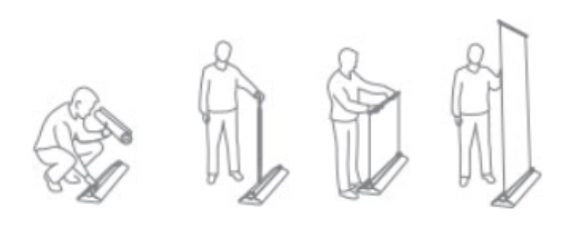
Assembly:
- Remove the folded pole from the bottom of the base. The pole should have been securely locked in place for transportation.
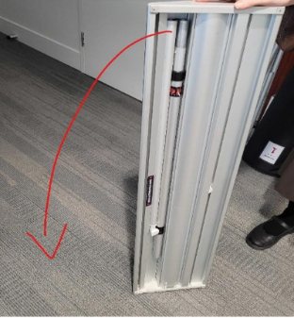
- Place base on ground. The interchangeable cylinder should already be inserted.
- Slot the two halves of the pole together. The elastic cord inside will guide it correctly. Don’t twist or extend the pole just yet.
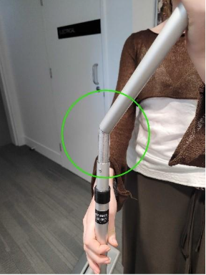
- Place pole in base, with the plastic lip at the top of the pole facing outwards.
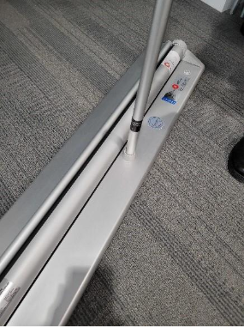
- Pull the banner up to the top of the pole. There is a tiny notch in the top beam of the banner that clicks neatly into the plastic lip at the top of the pole.
(This is an important safety step so please make sure the notch is securely in place before proceeding.)
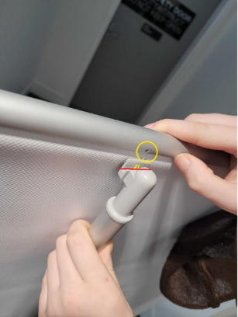
- The banner should now be half-way raised.
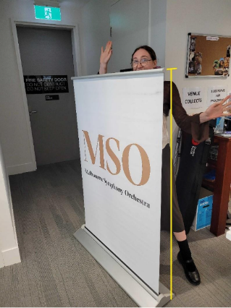

- Using two hands carefully twist the upper half of the pole in a counterclockwise direction.
There is a black sticker on the pole, showing you where to hold your hands.
You’ll feel the inner pole loosening.
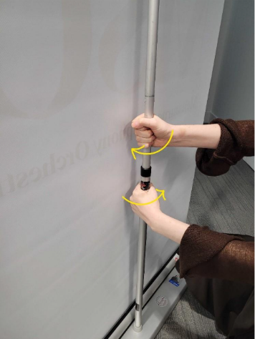
- Raise the inner pole to its full height, and twist clockwise to re-tighten it.
The pole and banner should now be at full height.
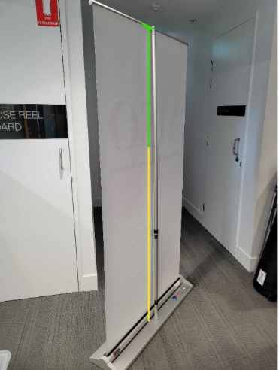

Disassembly:
- Using two hands, carefully twist the inner pole counterclockwise to loosen it.
Warning! As the inner pole loosens, you’ll feel the tension in the banner trying to snap back into place. Please use caution and get a second person to assist you if required.
Lower the pole to half-height and the lower pole clockwise to tighten it.
- With the banner at half-height, carefully detach the top of the banner from the pole.
You might need to stretch the banner up to detach the notch from the plastic lip of the pole.
Carefully lower the banner into the cylinder at the base.
- Remove the pole from the base and fold the top half over.
- Insert the pole into the underside to the base. You’ll know it’s correctly in-place when it’s making a snapping noise.
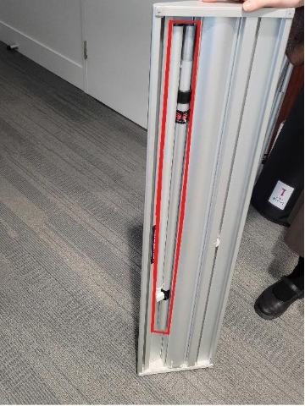

Hamer Hall
Where do I go?
Hamer Hall is located at 100 St Kilda Road, Southbank. You'll need to enter via Stage Door, which is around to the left of the central entrance. From there, you'll be given a pass and storage room key, and can be directed through the back hallway and upstairs to the Box Office. The MSO VIP Box Office Computers are on the farthest right-hand side when looking at the Box Office.
Who do I speak to about Ticketing Issues?
Arts Centre’s Box Office will be directly to your right when seated at the MSO VIP Box Office. Because our tickets will be consigned to them, they'll be able to check house numbers, availability, names of customers, and reprint or pull comps if need be.
What needs to be brought to the venue?
Relevant banners (detailed in concert sheet sent ahead of shift). Other required amenities including ticket stock, season brochures, lost ticket books and BO signage (open and QR) are stored at Hamer Hall's counter/closet permanently and are restocked/replaced during regular midweek venue runs. If you've noticed that we're low on one of these items or if they're damaged, please flag it in the concert report.
What needs setting up?
1x FOTMSO Banner, 1x MSO Generic Banner (plus other relevant banners if required) in the foyer. You'll also need to log on to the Box Office computers.
Anything else?
The password for the Box Office computer is Beethoven19! There will also be season brochures, programs, and other material in the storage room behind the Box Office computers.
King-size/Bariatric Chair
For customers needing a larger chair, this can be booked the same as a wheelchair space booking, but please note in the CSI to place a Bariatric Chair in. Just had a look at the order - most suitable would be H53-54 (with the chair to be placed in H54-55). The dimension of the chair is below:
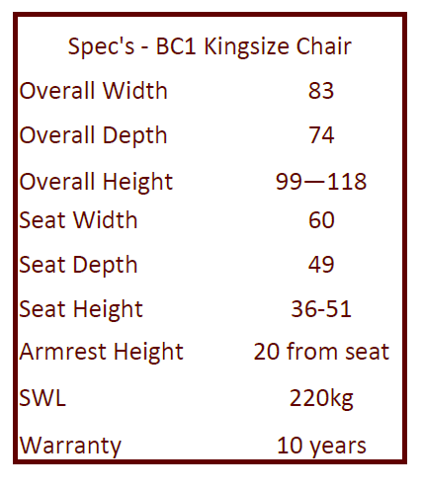

Melbourne Town Hall
Where do I go?
Melbourne Town Hall is located at 90/130 Swanston St. You can head up the main stairway, and the foyer is right at the top through the doors. You don't need anything specific to get in but may need to tell Security you're with MSO.
Who do I speak to about Ticketing Issues?
We're the only Box Office at MTH! Please ask your TL or SUP on call.
If it's a broad ticketing issue, it may be good to flag with the front of house team (operated by ACM).
What needs setting up?
1x FOTMSO Banner, 1x MSO Generic Banner in the foyer.
There will be 2-3 long tables to the left when entering MTH. On these, please set up 2x laptops, mini-BOCA, eftpos machines, Wi-Fi dongles, ticket alligator, and programs for payment. The power point is behind the fake windows behind the table.
Anything else?
The farthest table to the left, when facing the tables, is reserved for the cloakroom.
St Johns Ambulance are also to the left of the Box Office and attend in case of medical emergencies.
The Balcony at MTH is very steep without much in the way of handrails. Customers can be relocated if needed. There is an Organ Recital at 6:30pm for Town Hall performances, unless otherwise directed. Audience members will need a ticket to the performance to attend the Organ Recital.

Melbourne Recital Centre (MRC)
Where do I go?
Melbourne Recital Centre is typically open when our Box Office arrives, so you can enter through the main doors, and the Box Office is straight ahead. If you have any issues, Stage Door is around the corner to the right when facing the front doors.
Who do I speak to about Ticketing Issues?
MRC Box Office will be directly to your left when seated at the MSO pop-up Box Office. Because our tickets will be consigned to them, they'll be able to check house numbers, availability, names of customers, and reprint or pull comps if need be.
What needs setting up?
1x FOTMSO Banner, 1x MSO Generic Banner in the foyer.
There will be a table with a black tablecloth to the left of the MSO Box Office when approaching the Box Office. There you will need to set up 2x laptops, eftpos machines, and prepare programs and lost ticket passes.
Anything else? MSO performances take place in the Elisabeth Murdoch Hall, one level up. There are sometimes other performances at the Primrose Potter Salon at the same time, which is on the same floor as the Box Office.

Iwaki Auditorium
Where do I go?
Iwaki Auditorium is inside the ABC Building, to the far right of the building when facing the front. You'll need to enter via the main ABC entrance, as typically the Iwaki doors are locked when we arrive.
Who do I speak to about Ticketing Issues?
We're the only Box Office at Iwaki! Please ask your TL or SUP on call.
What needs setting up?
There should be 1-2 tables set up in the Iwaki foyer. On these, please set up 2x laptops, eftpos machines, Wi-Fi dongle, programs if available, and merch if available. Please have HowScan scanners ready if available.
Anything else?
Typically, we have one person on general Box Office/ticking enquiries at the table, one person on merch/program purchasing at the table, and one person at the Iwaki auditorium doors checking/scanning tickets or marking off names from the performance seating book.
For Iwaki performances, there are two security guards. One is stationed at the front of Iwaki doors, and the second is stationed down the hallway to scan people into the ABC foyer bathrooms.

Robert Blackwood Hall
Where do I go?
RBH is located at 49 Scenic Blvd, Clayton. You'll be given a cab charge in order to catch a taxi from ABC to RBH. Once at the taxi bay in Clayton, the Stage Door is the front small door of the building. The main foyer doors are around to the left. Inside, to the right of the entrance doors, is a small Box Office table where we can set up.
Who do I speak to about Ticketing Issues?
RBH Box Office will be to your right when seated at the MSO pop-up Box Office. They are inside a walled office, but there is a little windowed section where you can talk to the team. Because our tickets will be consigned to them, they'll be able to check house numbers, availability, names of customers, and reprint or pull comps if need be.
What needs setting up?
1x FOTMSO Banner, 1x MSO Generic Banner in the foyer.
On the pop-up Box Office table, you will need to set up 2x laptops, eftpos machines, Wi-Fi dongle, mini BOCA, and prepare programs and lost ticket passes.
Anything else?
There is often a pre-concert talk at RBH in the foyer.

MCEC Plenary
Where do I go?
The Plenary is inside the Melbourne Convention & Exhibition Centre, at 1 Convention Centre Pl. There is signage from the entrance leading to the Plenary, as the MCEC is quite a big space. The Box Office team meets outside the Plenary itself, at the pop-up box office.
Who do I speak to about Ticketing Issues?
We're the only Box Office for MSO at the Plenary! There should be a TL and Rowan on site for any questions.
What needs to be brought to Plenary venue shifts? 2 x Laptops (LT bags include mouse, charger etc), Banners (as specified in concert sheet), 2 x EFTPOS machine, Wi-Fi box, 2 x Power Board, Extension Cord, Gaffe tape, Ticket Stock, 5 x Season Brochures, Lost Ticket Book, Stationary (Pens, notebook, scissors, blue-tack, sticky tape), BO Open Signage, Confidential Waste Folder, BOCA printer, QR Code Signage, Crocodile (Ticker Sorter).

Sidney Myer Music Bowl
Where do I go?
SMMB Gate 7
What needs to be brought to SMMB venue shifts?
2 x Laptops, Banners (as specified in concert sheet), 2 x Square EFTPOS machines, Wi-Fi Box, Power Board, Extension Cord, Gaffer Tape, Black Tablecloth, BOCA Printer, Ticket Stock, 5 x Season Brochures, Stationary (Pens, notebook, scissors, blue-tack, sticky tape), BO Open Signage, QR Code Signage, Confidential Wase Box/Folder.
Who do I direct to for ticketing queries?
As SMMB is exclusively ticketed by Ticketek, queries must be directed to their entry counter if in relation to that day's performance. Our presence is solely for questions about other performances and general sub/customer queries.

CUSTOMER AND PRODUCT OVERVIEW

First Look Seats
Webpage: mso.com.au/first-look-seats
- FAQs + T&C link available on this page
General:
What is it:
- An accessible price to encourage new audiences/those who may want to attend MSO, but haven't been able due to cost of full price tickets, can attend – with an aim of sharing the MSO experience with as many Melbournians as possible.
- Who is eligible: New audience (no previous ticket purchase history)
- How many concerts/tickets can they book: 3 x concerts only, up to 4 tickets per concert
- Cost: $20 per ticket + $3 transaction fee per order
How to book:
- eDM will be sent to eligible customers
- eDM will include a link to landing page, can book seats from this page only (price not available via What's On or standard event landing pages)
- People can gain join the mailing list for future releases by signing on the webpage.
- Anyone can purchase the price via this webpage.
  - We will monitor customer behaviour and eligibility for the list.
- Allocation of seats for concerts - 50 seats at HH & SMMB, 30 seats at smaller
- venues First concert available 29 Jan --> via Ticketek

Other notes:
- Exchanges:
  - Straight refund (minus $3 transaction fee) if someone with First Look Seats can no longer attend their concert
  - i.e no exchanges into future concerts
  - Credit available
How to check eligibility within customer accounts
Overview tab: Data Source = First Look MMM YY
- i.e First Look Feb 26
- Note: Not editable by Box Office.
- For customers who sign up via website – as a reference of their import source
Attributes
- First Look Usage = 1,2, 3 etc
  - Will track the number of concerts a customer has booked with First Look tickets.
  - IMPORTANT: Not editable by Box Office
  - While the maximum to book should be 3, the count could go above this. Once a customer has reached 3 concerts, they will be removed from the email list.
  - This is updated automatically on a nightly basis from ticket history. Noting externally ticketed concerts (Ticketek/SMMB and Frankston) will be delayed as these need to be imported after the concert date.
- First Look Email = Yes
  - Customer with this will get onto the monthly release email list
  - Will appear on accounts who sign up via website
  - Can be added by Box Office
  - Please note they also need to be opted-in (Email Contact Permission = Yes) to receive the email.

Processing First Look Seats on Tessitura
- Make sure the customer has the attribute First Look Email = Yes
- Order parameters
- Source code: 63127
- MOS: 1. Single Tickets
- Price type: FIRSTLOOK
- Price reserve: ‘F’
- Check that $3 transaction fee applies
- Finish transaction as normal
FAQ’s for BO
- How do I sign a customer up for First Look Seats if they’re eligible?
  - Create a constituent for the customer
  - Add an email address and set contact permission to Yes
  - Add the First Look Email attribute and set to Yes
- Can eligible customers purchase First Look tickets more than a month in advance? (e.g. they want to buy Jurassic Park First Look tickets in February)
  - No, First Look Seats are mapped & released 1 month before. They will have to wait until seats are released

Programs
Programs are available for some, but not all, performances and patrons.
Typically, programs are available at core subscription performances. Previously subscribers have been sent a 'subscriber card', which they could show to receive their program. From 2024 onwards, we stopped sending cards and subscribers now show their tickets, which will have the subscriber status printed on the left.
Subscribers, Donors and Gold FOTMSO all receive free printed programs.
For all other customers, printed programs are $5 each. Programs can be purchased on the night, or pre-purchased online alongside tickets.
Free digital programs are sent out in the pre-concert reminder, available via the digital program banner at the concert, and available here.
Bumper Book:
2026 Bumper Book.xlsx

Price Types
List of common price types:
Price Type | Details
STAND | Standard - single ticket purchaser | No concession entitlements
CONC | Concession - single ticket purchaser | Eligible concession entitlements
ADD STA | Additional Standard - Current Subscriber purchaser | Getting tickets to concert outside of subscription package | Not exchange |No concession entitlements
ADD CONC | Additional Concession - Subscriber purchaser getting tickets to something outside of subscription package | Not exchange | Eligible concession entitlements
C CARD | Companion Card - allocated with a paid CONC/STAND ticket | Companion Card number and expiry must be added to attributes before purchase is finalised.
COMP | Complimentary ticket - no charge ticket
CHILD/U18 | $20 Child/Under 18 Price Ticket - For attendees ages 2-17 years | A-D Reserve | Can only be redeemed on selected concerts
EX S SNG/PKG | Exchange Standard Single Ticket/Package (Subscriber) - Standard price type for a concert being exchanged into | No concession entitlements
EX C SNG/PKG | Exchange Concession Single Ticket/Package (Subscriber) - Standard price type for a concert being exchanged into | Eligible concession entitlements
GRP STN | Group Standard - a Standard ticket at a discounted price | Must be booked as part of 10+ tickets (STA/CON) to same performance day/time
GRP CON | Group Concession - a Concession ticket at a discounted price | Must be booked as part of 10+ tickets (STA/CON) to same performance day/time
STAFF | Staff ticket price - offers seating an price reserve discount | No quantity limit per concert
BRING | "Bring a Friend" Complimentary FOTMSO Offer | Gold x 2 (A-D Reserve), Silver/U35 x 1 (A-D Reserve/B-D Reserve) | Can only be redeemed on selected concerts
U35 | Under 35, $35 ticket | B-D Reserve | Can only be redeemed on selected concerts
STU MEM | Student Member $25 ticket | C-D Reserve | Can only be redeemed on selected concerts
STUMEMCOMP | Student Member Complimentary Ticket Offer | C-D Reserve | Can only be redeemed on selected concerts
SUB STA/CONC | Subscriber Standard/Concession - Used for purchase of Set Series Subscription | If Concession, we must have concession details in customer account.
CYO STA/CONC | Create Your Own Standard/Concession - Used for purchase of "Create Your Own" Subscription | If Concession, we must have concession details in customer account.
MOBTIX Mob Tix are a special allocation of tickets that allows First Nations peoples both within and outside Australia access to a discounted rate to certain concerts.

Concession Card Details
Carer Card
a new kind of concession card issued to the carers of people with accessibility or disability issues. Be careful about distinguishing the Carer Card (concession prices) from the Companion Card (free tickets). The concession applies only at Melbourne Town Hall and Chamber Series performances, similar to the Seniors Card.
Companion Card
issued when someone requires a companion to assist them to attend concerts, the Companion Card concession provides free of charge tickets to the companion. The person they are assisting pays their usual price (very often another concession).
Health Care Card
State Government-issued and means-tested cards that can be used to obtain concession prices at nearly all MSO concerts and subscriptions at Hamer Hall, Melbourne Town Hall, Melbourne Recital Centre and other venues.
Pensioner
State Government-issued and means-tested cards that can be used to obtain concession prices at nearly all MSO concerts and subscriptions at Hamer Hall, Melbourne Town Hall, Melbourne Recital Centre and other venues.
Seniors Cards
issued by the Victorian Government, not means-tested, eligible for MSO Concession pricing only at Melbourne Town Hall and Chamber Series concerts. Works more as a "proof of age" or ID card than a proper concession card.
Student
student members can obtain discounted MSO tickets to eligible concerts. The list of eligible concerts is subject to change without notice. Only concerts on the Student tickets listings apply for a student concession. A limit of 2 tickets per student at C reserve and under applies.
Veteran (with Department of Veteran Affairs white or gold card)
State Government-issued and means-tested cards that can be used to obtain concession prices at nearly all MSO concerts and subscriptions at Hamer Hall, Melbourne Town Hall, Melbourne Recital Centre and other venues.
War Widow
State Government-issued and means-tested cards that can be used to obtain concession prices at nearly all MSO concerts and subscriptions at Hamer Hall, Melbourne Town Hall, Melbourne Recital Centre and other venues.
Concession and health care cards - Seeking medical help - Services Australia

Subscribers and Subscriptions
Subscribers refer to customers who have purchased a set series subscription or create your own subscription (CYO) with us.
A Subscription refers to series or performances booked together as a package. The same seat(s) are reserved in every performance within the package (aside from CYO), and these seats are held and can be renewed each year. Commercial or Special Event concerts are not available as part of these packages.
Subscribers receive:
- No exchange fees
- Free concert programs
- Save up to 20% on subscription tickets and 10% on additional tickets
- Discounts on merch
- Pre-sale access to new concerts
Core Subscriptions we offer include:
- Thursday Nights Series (8 and 8 plus)
- Saturday Matinees Series
- Saturday Nights Series
- Quick Fix at Half Six Series
- MSO Mornings Series
- Town Hall Series
- Recital Centre Series
- Geelong Series
Other Subscriptions include:
- Jams for Juniors
- Classic Kids
- Chamber Series
*These subscriptions do not contain set seats that roll-over each year
Create Your Own (CYO) Subscriptions are packages where the subscriber chooses 5+ performances of their choice and bundle them together into a subscription. Some performances are ineligible to be included in a CYO Sub, like Jams for Juniors performances.
Child Price Subscriptions
Set Series / CYO Child Price Subscriptions - New for 2026
- Tickets are listed as $20 for all eligible child price concerts, and Concession pricing for the others.
- Any subscription that has a child priced subscription in it - will only have the delivery method as Collect at Venue - at the first concert of the subscription year.
- This is to verify the age of the attendee, and they are able to attend solo and/or are eligible for the child price tickets.
- The PAH/mobile ticket option will be hidden at checkout if the order has these price types.
- If they have selected a digital method, if a standard price has also been selected in the subscription, it will be updated at the cart and they will receive a message informing them.
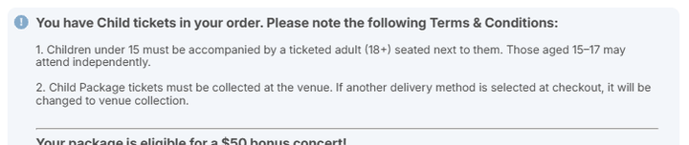
NOTE: We will be monitoring Child Price subscriptions, to ensure the customer is in the correct age range.

School Bookings
See School Bookings procedure for procedure
School bookings are bookings by a school to a designated school event.
School bookings and performances are:
- At the discounted rate of $9 per ticket for designated schools' performances and Meet the Music concerts
- Eligible for an excursion subsidy for schools with an ICSEA lower than 1000
- Sent via invoice payment method, and must be paid 2 weeks prior to performance
- A list of schools' performances and resources for teachers can be found here.
- If Teachers/Schools are asking about the 'ICSEA below 1000' subsidy, it applies to transport and staffing only - not ticket booking. These are tracked and approved by the schools' program person (tbc)
- Even schools that are applicable for the subsidy can't get discounted tickets - they still pay $9 per head.

School Booking Request Form

Geelong School Booking Request Form
- Teachers are highly encouraged to make school booking requests via school booking request form to ensure accurate and correct school and teacher information.
- If teachers are unable to submit a request via form for any reason (e.g. web issues), you may process the booking over the phone/email; however, please add the request and all relevant info to the tracker

Ticket delivery
For schools concerts and open rehearsals: no e-tickets or collect at venue tickets. Schools can arrive on the day of the performance and speak with FOH staff, who have a list of the schools and their assigned seating area. They will then be ushered to their seats.
For Meet the Music concerts: e-tickets will be sent to teachers 2 business days before the concert
For Geelong concerts: e-tickets will be sent 72 hrs before the concert c/o Geelong Arts Centre. Schools get tickets to MSO Geelong concerts B-C reserve for $30, with an additional 10% discount for 10+ tickets.

Composing Australia
The Composing Australia performances are considered School Holiday bonus events. This means that teachers will not be organising excursions, rather, students will be able to book the $9 tickets to attend with their parents. Booking links will be sent to the teachers who submitted EOI via booking form in March.

Jams for Juniors
Jams for Juniors are workshops for infants and toddlers where the focus is on musical development in early learning. The workshop runs for 30 minutes, and the recommended age is roughly 0-5 years old. Jams for Juniors performances can also be purchased together as a subscription.
All attendees (children and parents) require tickets. There is no babes-in-arms policy.
For single ticket purchases, only one $15 exchange fee is charged per booking.
Jams for Juniors upcoming performances can be found here.
Signage for Jams for Juniors can be found here.

Classic Kids and Classic Kids Relaxed
Classic Kids performances are short, fun and interactive performances at Hamer Hall for children. The recommended age is roughly 5-12 years old. Classic Kids performances are an hour in length and include narration, making them a good entry point to the concert experience for children.
For single ticket purchases, only one $15 exchange fee is charged per booking.
Classic Kids Relaxed performances are relaxed, sensory-friendly performances designed to be a comfortable place for children of all ages, as well as audience members with autism, a disability or sensory sensitivity. Classic Kids Relaxed performances are the same repertoire as Classic Kids, typically performed on the same day.
At Classic Kids Relaxed you can expect:
- A downloadable visual story emailed to ticket holders ahead of the concert
- A relaxed attitude to noise and movement during the concert
- Lights to stay on during the concert
- Open doors and chill-out break areas
- General admission seating with space for freedom of movement
- Friendly, trained staff
Classic Kids and Classic Kids Relaxed performances and information can be found here

Under 18/Child Price Tickets and Babes-In-Arms Policy
Our Babes-in-Arms policy allows babies 0-2 to be held on a lap without a ticket. This policy covers most performances, except from Jams for Juniors, where every person attending requires a ticket.
Under 18/Child Price Tickets are available to children and young people aged 0-17. These tickets are $20 and are available for most MSO performances across A-D reserve until allocation exhausted.
- Children under 15 years must be supervised by a ticketed adult, and seated beside them.
- Children aged 15-17 can attend without an adult, and remain seated by themselves.
- Children aged 15-17 cannot supervise children under 15. They must have an accompanying adult aged over 18 years seated with them.
A list of performances eligible for Under 18/child price tickets is available here.

MEMBERSHIPS

Adding eMemberships to a Constituency
Adding an e-membership attribute in a member's Tessi constituency ensures that their membership is received digitally, including the welcome pack.
This is done by going into the Attributes tab, then selecting 'eMembership' as the attribute and the attribute value as 'Yes'. Then save and close.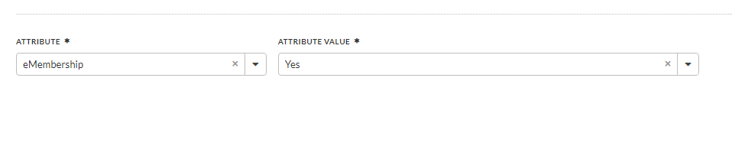

Friends of the MSO Members (FOTMSO) | Memberships
Friends of the MSO Members (FOTMSO) refer to customers who have purchased a Gold, Silver or Under 35 Friends of the MSO Membership with us.
Members are not the same as subscribers and do not get concerts with a purchase of a membership but will occasionally receive free tickets or discount offers.
2026 Memberships are valid from date of purchase until 31 December 2026.
A Friends of the MSO Membership is a type of membership that allows those who join to access a suite of additional benefits. Memberships are available in the following levels:
- Gold Member ($249)
- Silver Member ($109)
- Under 35s Member ($75)
FOTMSO Members receive:
- Ticket and partner offer.
- Priority and presale access
- Invites to special events such as open rehearsals and season launch
- Complimentary 'Bring a Friend' vouchers. Eligible concerts here. Source code: 42377; Price type: BRING
- A digital or physical membership welcome pack once they join (inc. drink vouchers and other collateral).
- Under 35 members can access 2x $35 tickets (B-D Reserve) to select concerts. Under 35 eligible concerts can be found on the website.
Welcome Packs are sent out weekly on a Tuesday, depending on whether the member has selected a physical or digital welcome pack. We can check if a pack has been sent on Tessi:
- Physical membership packs are sent on the Tuesday, and we can check this in their Tessi account under Attributes > FOTMSO Welcome pack sent.
- Digital membership packs are sent weekly, and we can check this in their Tessi account under Attributes > (e-membership > yes)

A full list of membership benefits are available here
A breakdown of different types of memberships is available here on pg. 3-4

Friends of the MSO Members (FOTMSO) | Creating & Sending Membership Pack
Friends of the MSO Members (FOTMSO) refer to customers who have purchased a Gold, Silver or Under 35 Friends of the MSO Membership with us.
Members are not the same as subscribers and do not get concerts with a purchase of a membership but will occasionally receive free tickets or discount offers.
2026 Memberships are valid from date of purchase until 31 December 2026.
A Friends of the MSO Membership is a type of membership that allows those who join to access a suite of additional benefits. Memberships are available in the following levels:
- Gold Member ($199)
- Silver Member ($99)
- Under 35s Member ($69)
- Geelong Member (only available from the Geelong Friends of the MSO organisation, not associated with the Geelong Arts Centre)
FOTMSO Welcome Packs Include:
- Gold Member: Welcome letter, 1 x 2025 Gold FOTMSO Membership Card/Pin collect voucher, 2 x Bring a Friend and 2 x Friends VIP Drink Vouchers
- Silver Member: Welcome letter, 1 x 2025 Silver FOTMSO Membership Card/Pin collect voucher, 1 x Bring a Friend and 1 x Friends VIP Drink Voucher
- Under 35's Member: Welcome letter, 1 x 2025 U35's FOTMSO Membership Card/Pin collect voucher, 1 x Bring a Friend and 1 x $35 Access Voucher
Welcome Packs are sent out at weekly on a Tuesday, depending on whether the member has selected a physical or digital welcome pack. We can check if a pack has been sent on Tessi:
- Physical membership packs are sent on the Tuesday, and we can check this in their Tessi account under Attributes > FOTMSO Welcome pack sent.
- Digital membership packs are sent weekly, and we can check this in their Tessi account under Attributes > (e-membership > yes)
Tuesday Process for Creating and Sending Membership Packs
- Marta will provide the Tessi Report of new members from Tuesday (the previous week) up to current week, this will be separated for the different membership types
- Team Leader will do the mail merge and print of labels removing any "address to be supplied or unknown address"
- Welcome packs are to be made for each new member, checking Tessi that the membership type is correct
- Labels can be added to the envelope, and they can be sent out. This should be completed on the Tuesday.
NOTE:
- Any addresses still to be advised:
- Should be added to that week's Asana task "Check if these customers would like to be e-FOTMSO" with Constituent Number, Full Name and Membership type to follow up with customers.
- Once addresses are provided, member packs to be sent out that day, and the name crossed out on the Asana ticket's list
- If no response provided, they are to be made e-FOTMSO on the Tuesday morning, and the Asana ticket updated to the current week.
- FOTMSO Pin Collection:
- All Pin types are available to collect at Hamer Hall MSO VIP desk, when we are there for a Concert.
- The Member should provide the "Pin Collect Voucher" to the Box Office Team Member
- Once the pin is provided, the voucher is retained by MSO and a CSI added to their Tessi profile using Category → FOTMSO Welcome Pack Sent → CSI will be Date/name - 2025 Membership Pin collected
A full list of membership benefits are available here. A breakdown of different types of memberships is available here on pg. 3-4

Student Memberships
Student Members are local or international full-time students who have purchased a student membership with us.
A Student Membership is a $25 membership which allows students to access discounted tickets. In previous years, this included unlimited access to MSO.Live, however, that service was discontinued in 2025.
Student Members receive:
- Receive x1 complimentary ticket (valued $25) upon joining
- Access to up to two $25 tickets (C-D Reserve) to select concerts, found here.
- No exchange fees for student tickets
Person attending with the Student Member on their second Student Membership ticket does not need to be a student or member with us.
Delivery Method: Collect @V enue
The Student Member must present 1 x Valid Student ID upon collection. These tickets are printed with the general venue collects for a concert and, for Hamer Hall concerts, are given out by ACM Box Office once the Student ID is sighted.
Tickets must be booked by 3pm the day of the performance or by 3pm the Friday before weekend performances. Eligible concerts are subject to availability and may change with little or no notice.
Student Membership T's and C's
How to check if they've claimed the comp ticket
The quick way: Check ticket history
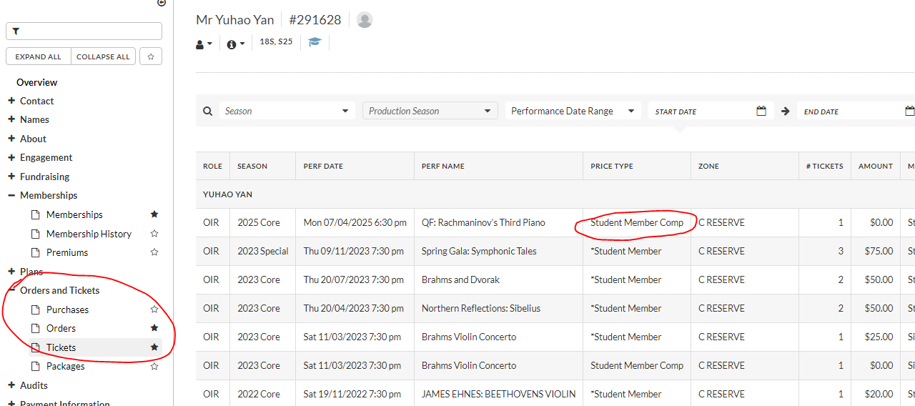

The long way:
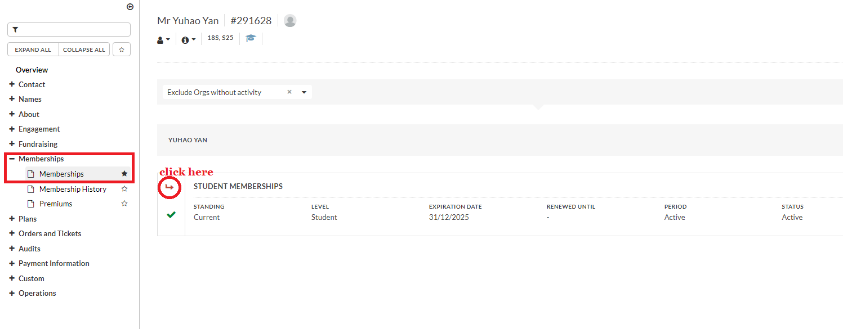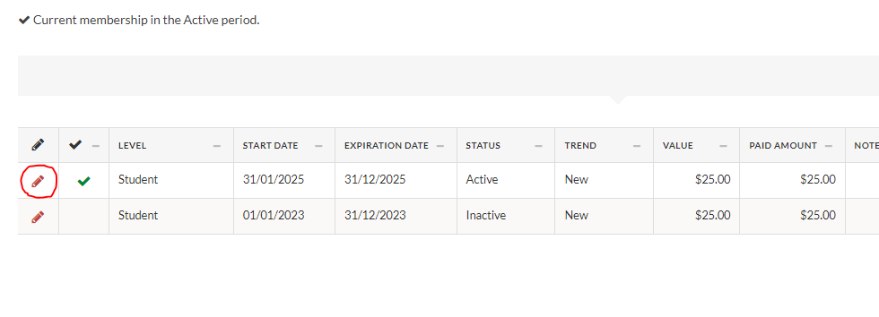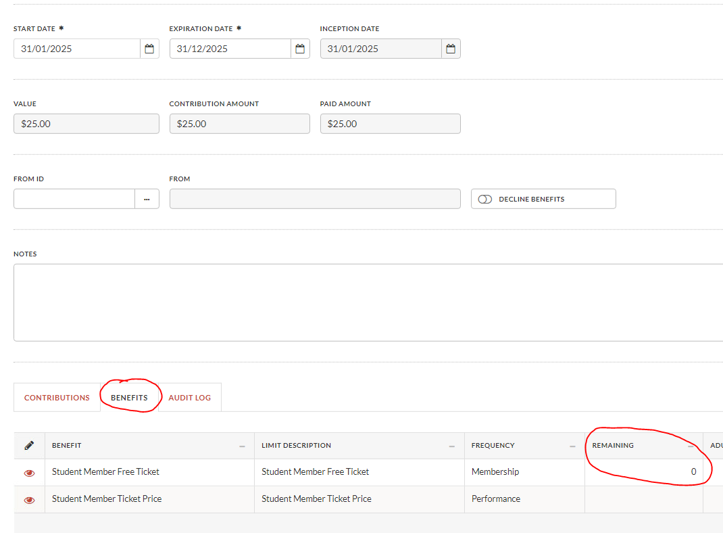
“Remaining" will be zero if comp has been claimed
Tickets to free events (Open Rehearsals, Cybec etc) - 2 tickets per member
Friends can access up to two tickets per event that they're invited to RSVP for.
Gold Membership - Gala event B Reserve ticket - upgrade at cost Gold members are offered up to two complimentary B Res tickets to a Gala event of their choice. They can choose to pay to upgrade to A or Premium reserve - they must simply pay the difference between B and their new reserve. Add a B reserve ticket to the cart to calculate the difference and adjust the Prem or A reserve ticket to match.

Staff Tickets

Comps
Complimentary tickets to MSO performances are available to Staff, Chorus Members and Musicians. Two complimentary tickets are available per date of performance.
Staff, chorus members and musicians can request comp tickets through the comp form available, or by emailing the comp email (comps@mso.com.au) which is handled by Marta. If staff, chorus members or musicians call or email through to request or discuss comps, please direct them to the form or email. We are unable to process comps for staff at the Box Office unless directly authorised.
Deadlines:
- Tuesday - Friday concerts: 3pm the day before the concert date
- Saturday - Monday concerts: 3pm the Friday before the concert date
Allocation:
- Casual musicians may use the form to request complimentary tickets for concerts they’re performing in. Concert selections will be updated every Monday.
- Chorus members can receive up to 10 complimentary tickets per year, max of 2 per concert. For any tickets after their allocation is exhausted, they can access the STAFF price type.
E-tickets will be sent from 2 business days before the concert

Staff/Chorus Pricing
Staff pricing is available for performances where comps are not available, or in addition to complimentary tickets. Staff, chorus members and musicians should have a 'Staff' attribute, which will allow the 'Staff' price to be visible when putting together an order.
The staff pricing discount allows staff to pay one reserve down from the chosen reserve. So, for example, Staff can book in a Premium ticket at an A Reserve price, and so on. There is no discount for D Reserve as it's the lowest reserve.
As with comps, casual musicians are only able to request staff pricing for performances they are performing in. They won't have a staff attribute, and Orchestra Management or Comps will usually endorse them.

Staff Ticket Exchanges
MSO Staff are entitled to fee-free exchanges. For any exchange where there is a price difference between the ticket values, the difference is payable at the time of the exchange.
- If the new concert/date you select is cheaper than your existing ticket value, the excess value will be absorbed as part of the transaction.
- If the new concert/date is more expensive than your existing ticket value, the additional balance must be paid to finalise the exchange

TICKET CHANGES

Exchange Ticket Price Explainer
When processing an exchange, the new tickets in the exchange order should have a price type that starts with 'Ex' (standing for exchange). That allows us to price match to the appropriate amount. After that, we can use the below guide to find out which price type to use:
Ex S Pkg
Exchange Standard Package. This is used when the customer exchanging is a Subscriber and the original ticket was not a concession.
Ex S Sng
Exchange Standard Single. This is used when the customer exchanging is a not Subscriber and the original ticket was not a concession.
Ex C Pkg
Exchange Concession Package. This is used when the customer exchanging is a Subscriber and the original ticket was a concession.
Ex C Sng
Exchange Concession Single. This is used when the customer exchanging is not a Subscriber and the original ticket was a concession.
Note:
Exchanged tickets should match ticket to ticket. So, for example, if the original order was one standard ticket and one concession, and the customer was not a subscriber, the new tickets in the order would have the Ex S Sng and Ex C Sng price respectively.

Change of Mind
If customers contact us within a day of purchasing, requesting amendment/change/refund of order, we can action under change of mind.
E.g. Customer purchased at 8:57am on Monday, then emails us 12pm Tuesday requesting refund because they booked in error - we can action under "change of mind".
Examples:
- I meant to book five seats together, but one is accidentally in the row behind - help!
- I booked and then told my partner who reminded me we have a wedding that day!
- I meant to book for the Sat 1pm but booked for the Sat 7:30pm!
What we can offer:
- Fee Free Exchange
- Please CSI Under Payment > Exchange Request for initial contact
- Full Refund of order
- Please CSI Under Payment > Refund Request
If it is outside next day, you will need to check with TL/Supervisor before processing.

Exchange FAQ's & Cheat Sheet
For general exchange information, please see details here
For Geelong exchange information, please see details here

General Venue Exchanges
If a customer is unable to attend a performance with us, they can exchange their ticket for another MSO performance.
The guidelines for exchanges are:
- The ticket to be exchanged must have originally been sold by the MSO Box Office (and not ACM, etc.) and be moving into a performance also ticketed by the MSO.
- MSO tickets must be exchanged to another performance within the same concert year.
- The MSO Box Office must be contacted at least three hours before the original performance time to process an exchange.
- A new order with MOS > Exchange must be used when exchanging a ticket.
- Once started, an Exchange must be finalized within 3 business days (and if the Exchange is incomplete, all held tickets will be released)
Exchanges are fee-free for:
- Patrons
- MSO Guardians
- Subscribers
- FOTMSO Gold members
- Student members
- Anyone with Staff price* tickets.
For everyone else, there is $15 exchange fee per ticket. This should be automatically added to the order when in the Exchange Mode of Sale.
Jams for Juniors and Classic Kids - single ticket purchases, only one $15 exchange fee is charged per booking.
In addition to fee's, customers (including subscribers) must pay the difference in ticket cost when exchanging. This includes when a performance is more expensive, when moving to a more expensive day, when moving to a higher reserve, and when there has been a price increase for a performance. We can minimise this cost by moving to a lower reserve, if the customer would like.
UPDATE: If the new ticket is less expensive, this price difference will be absorbed during the exchange, and no gift card will be issued
For Larger Price Difference:
- If the difference is more than $25, once exchange fees have been absorbed if applicable, the BO team can check with TL/SUP about returning this amount to a gift card.
- If the difference is greater than $75, the BO team can automatically return the amount to a gift card.

Geelong Arts Centre (Costa Hall), West Gippsland, and Frankston Arts Centre have different exchange policies. Please see the relevant details in the above links or under Ticket Change.

*(Staff price tickets only apply for MSO staff, musicians, and chorus members for certain events.)

Geelong Arts Centre Exchanges
As of 2024, for the first time, MSO have an allocation of tickets to sell to Geelong concerts. Exchanges can be facilitated from MSO performances to Geelong/Costa Hall performances. Currently, exchanges from Geelong to MSO will need to have their tickets refunded by GAC and repurchased with us.
Up to one week before each performance:
- Subscriber exchanges can happen in our system (!!)
- Additional ticket purchases are available
- Single ticket purchases are available
- Geelong can be included in CYO packages
To note:
- Customers will receive a ticket voucher from MSO (samples attached)
- If a customer opts to receive e-tickets, Geelong will issue the actual ticket 72 hours prior to the performance
- If a customer opts to receive physical, they will need to exchange the voucher at the GAC Costa Hall Box Office - encourage customers for digital or venue collect
From one week prior to the performance, all availability will be consigned back to GAC. Exchanges and purchases can still occur but needs to be coordinated with Marta.
Other:
- Geelong tickets show the subscriber price type which enables free program redemption

West Gippsland and Frankston Arts Centre Exchanges
Unlike ACM, MRC, Costa Hall, and many other venues, we neither independently ticket nor have an allocation of tickets for West Gippsland and Frankston Arts Centre performances. Because of this, we are unable to exchange tickets between these performances and other MSO performances.

Credit Requests / Medical Certificate
If a customer is unable to attend a performance due to illness and needs more time to exchange then our deadline permits, they can receive the value of their tickets as a credit in the form of a gift card.
Only the value of the tickets can be used towards a credit request. Any fees (transaction/postage fees) or donations processed at initial purchase are not returned for the purposes of credit.
Credit requests have the same rules as an exchange, except:
- Credit requests require a medical certificate to be provided within three business days of the request before it can be finalised.
- Instead of applying the funds to another performance, the funds are added to a gift card so a new performance can be chosen when the customer is well.
Credit requests have the same guidelines as exchanges:
- The ticket to be credited must have originally been sold by the MSO Box Office (and not ACM, etc.)
- The MSO Box Office must be contacted at least three hours before the original performance to receive a credit.
- A new order with MOS > Exchange must be used when providing a credit.
Credits are fee-free for subscribers. For non-subscribers, there is $15 exchange fee per ticket. This is because customers are still moving between concerts. A credit just extends the time under which they need to book in a new performance. This fee should be automatically added to the order when in the Exchange Mode of Sale, and thus is deducted from the gift card.
Gift Cards are valid for 3 years by law, so customers have 3 years from the time of credit to purchase another performance.

Price Difference
If the new ticket is less expensive, this price difference will be absorbed during the exchange, and no gift card will be issued
For Larger Price Difference:
- If the difference is more than $25, once exchange fees have been absorbed if applicable, the BO team can check with TL/SUP about returning this amount to a gift card.
- If the difference is greater than $75, the BO team can automatically return the amount to a gift card.

Refunds
There are two situations where tickets are refundable:
- An event is cancelled, rescheduled or significantly changed, as outlined in the LPA Ticketing Code of Practice.
- The ticket has been purchased within 24 hours of the customer contacting us, as per our Change of Mind policy.
If customers are now no longer able to attend a performance, we can offer an exchange (with fees as applicable), that they pass the tickets on to friends and family, or they donate the cost of the tickets as a tax-deductible donation to the MSO. If they are ill and have a medical certificate, they may receive a credit.
In rare extenuating circumstances, we may offer a refund or refund to gift card as a gesture of goodwill. In these instances please do not promise a refund, but let the customer know we will escalate their request, CSI, ask for the details in writing (via email) and let a supervisor know.
What if they paid using a Gift Certificate?
They can only be refunded to another gift certificate. If they paid any additional amount using a credit card, that amount can be refunded to their card. Please contact the customer to check if they wanted a GC for the whole amount rather than a partial refund/partial gift certificate.

Ticket Resale (Tixel)
It is against our ticketing terms and conditions for customers to resell their tickets.
We don’t suggest, encourage or endorse Tixel or any other platform to customers.
Our terms and conditions state:
No ticket sold through either the MSO or any authorised sellers is eligible for re-sale other than where explicitly approved by the MSO.
You can find the ticket change email template on Asana Exchange Request Template

Payments
Instalment Plans
Subscribers who purchase a subscription with us during the subscription period are eligible to pay via instalment plan.
Important - please make sure you are in MOS: Subscriber and not Subscriber (Web)
Instalment plans allow customers to pay for their subscription over four payments, deducted on the first Friday of every month. At the time of booking, the customer pays:
- Any fees ($10 instalment fee, plus transaction and postage fees if applicable)
- Contributions
The remaining ticket value is split into 4, with the first payment being deducted overnight following the completion of the transaction.
The remaining 3x payments are deducted over the following 3x months.

Instalment Plans - Payment Errors/Failures
Instalment plan payments are automatically deducted on the 1st Friday of each month of their plan.
Errors can occur for various reasons, such as
- Card has expired or cancelled due to customer issues
- The transaction was declined, likely due to credit limit, daily payment limit has been reached, or the funds are not available on the card
Please action as follows to resolve any instalment plan payment issues:
- Nicole will provide a report after the payments are processed on the Friday each month, listing any errors.
- Customers are to be contacted to be made aware of the issue and to follow up resolving this and taking payment. Asana tickets to be made for each one by TL.
- Please do not close the Asana ticket, until the payment is taken, the date should be amended to the following Thursday and the action/contact note updated on the ticket and in the CSI.
- To find where to process the instalment payment go to the customers constituency (CTRL+G page) then in the top left corner click 'Constituents' then go to 'View Invoices'. To pay, tick the box 'pay' then click 'payments' which will take you to the money bags entry. Type in the correct amount for the instalment and enter the Payment Method (credit card) and Apply Payment.
- If you need to check the schedule for the payments or update the dates, see on the 'Invoice List'/'View Invoices' and then click on the chicklet under 'Sch' and next to 'Yes'. If you make any changes, click 'Save Schedule'. If you need to update the credit card, then next 'Amount' click and add the credit card.

First Contact - Advise of payment error (and issue if known eg: CC expired), phone and email as applicable. Expected to correct by the following Thursday to avoid $10 late fee
Second Contact - To be completed by the following Friday, $10 late fee to be added from that Friday if no response. Phone and email customer, advising of second attempt to contact, $10 fee will now be added. Expected to correct the payment error by the following Thursday, to avoid cancellation of the Subscription.
Third Contact - To be completed by the following Friday. If no response to phone call or emails sent, confirm with Alison/Shannon and subscription will be cancelled - with money refund, less fees (including $10 late fee).

Donations/ Contributions
The process for adding donations in Tessi will differ depending upon the amount donated.
- All Donations $499 and below should be processed through the Contributions tab (up to date)
Donations to the MSO above $2 are tax-deductible. Donations $500 and above make a customer a Patron with us, allowing them special perks and benefits. If taking a donation of $500 or more, and the customer doesn't currently have a Patron attribute, we can let the customer know and suggest we connect them to Philanthropy.
In the rare scenario that a Philanthropy member isn't around, and a customer wants to donate over $500, please process as follows
- Donations $500 and above as in the Memberships tab of an order
- Fund: General Support
- Mode: Amount First
- Amount: $xxx
- Please let a Team Leader know and immediately email Philanthropy@mso.com.au
Receipts will be sent by Philanthropy. If anyone has a specific request about receipts, please email Philanthropy with the subscriber’s name and customer number (Philanthropy doesn't use order numbers, so always go by customer number)
If the customer donates via the website, and contacts us as they didn't intend to make the donation, we can refund the donation to them.
[Here's also instructions with pictures in our Philanthropy Scripts Guide]
Refund to Cancelled Card (ARN).
It's always best to confirm the validity of the card when issuing a refund. But sometimes funds get caught in limbo if a card account has been closed or a card cancelled (scams/fraud/etc.). In these situations, the funds don't always bounce back to us, and we need to use an Acquirer Reference Number (ARN) to help customer located their refund.
An ARN is a unique number assigned to a credit card transaction as it moves through the payment flow. It can be used by banks to help trace a refund if it appears to be missing.
Customers will need to give the ARN we provide to their cancelled card issuing bank.
ATTENDANT TO ACTION:
- If already contacting the customer, let them know that we'll issue them an ARN* which they can provide to their bank to track down the refund.
- CSI the exchange and refund under Payments > Refunds > Approved.
- Notify TL/Supervisor and move any related correspondence to FOR SUPERVISOR (see TL/Supervisor Instructions below)
- Once ARN is available, email the customer with the template below.
- CSI that the ARN has been provided to the customer and close the CSI.
TL/SUPERVISOR/MANAGER TO ACTION:
- Add order details to ARN Request Refund Register
- Email ST noting request has been added to spreadsheet
- Update CSI:
- "Sent ARN request to ST via ARN Request Refund Register"
- Once ARN is received - add task to Customer to Contact in Asana for Attendants to follow-up

Instalment Payment Date Calculator
Instalment Payment Date Calculator
It calculates the payment dates for you and will automatically tell you if there's an included 1-month grace period.
Alternatively, you can view payment plan dates by
  - Crtl + G — go to Constituents screen
  - Constituents (tool bar)
  - View invoice
  - click on chicklet under "Sch"
This will bring up a pop up showing upcoming payment dates and $
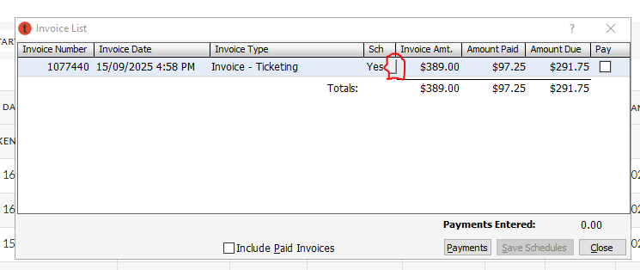

Refund by Bank Transfer
This should only be used when we cannot refund to a credit/debit card. If we have processed a refund to a cancelled card, please refer to Refund to Cancelled Card procedure first.
Before we can process a Refund by Bank Transfer, we need to have the following information:
- Bank Name
- Bank Branch
- BSB Number
- Account Number
- Account Name
- Email address for remittances.
Then:
- Notify TL/Supervisor and ensure all email records are in FOR SUPERVISOR/MANAGER folder.
- Once customers provide bank details, complete the Refund Request Form Template.
- Download the form and save a copy "[Customer number] - [Customer name]"
- Make sure that the details in the form match the info given by the customer.
- Email to boxoffice@mso.com.au with the following information:
- Attachments:
- Refund request form
- Email from customer with their bank details*
- Email Body:
- *If bank details were taken over the phone, please note here.
- Include any other details worth noting.
- Place email in FOR SUPERVISOR/MANAGER folder. Inform a TL/Supervisor and/or Manager once you’ve done this.
- CSI (PAYMENTS > Refunds > Refund by Bank Transfer) on the customer’s account with the following information.
- [Date] [Initials] 16/08/21 MA
- [Order Number]
- Amount refunding: $XXX.XX
- Refund method: Bank Transfer/Cheque
- Sent refund request to Managers: [Date] [Initials]
- Reason for refund:
TL/SUPERVISOR/MANAGER TO ACTION:
Once refund by Bank Transfer/Cheque is received, Complete following:
- Input refund request in Refund Request Tracking Register
- Email Finance noting request has been added to spreadsheet
- Update CSI:
- "Sent refund request to Finance via Refund Request Tracking Register"
- Check Customer Account, if there’s a valid order with funds for the refund on Tessi, place the money on account to avoid any accidental bulk refunds.
- Done!
Cheque Payment
- Once the order details are finalised, we can pay for an order using a cheque payment.
- Payment Method: Cheque – Ticketing
- Cheque – T Number, insert cheque number
- example below with T Number circled in red
- Make sure Cheque Account Name matches exactly with Tessi Payment Name
- Write your initials and order number on the back of the cheque
- Place cheque in Customer Experience Manager's drawer for banking and let them know.

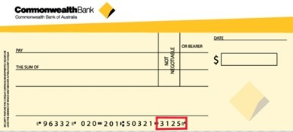

Gift Card
MSO Gift Cards are valid for 3 years, for any MSO ticketed performances, and available to purchase online or over the phone with us.
Physical Gift Cards:
- Can only be purchased via Box Office
- Must have the postage fee added to the order if posted
- Are found in the drawer beside BOCA/MSOWS13
Digital Gift Cards:
- Can be purchased via website or Box Office
- We can provide the name of the recipient and a note to them under the 'Gift Cert Recipient Name' and 'Notes' fields in the payment window respectively
- Are sent automatically via website, or through us via Print Order > Acknowledgement > Gift Certificate

FOTMSO Gift Card
Friends of the MSO Gift Cards are valid for 3 years, specifically to gift a FOTMSO membership, and can be purchased online (below membership list) or over the phone with us.
FOTMSO Gift Cards allow customers to gift a FOTMSO membership without needing to provide the recipient details, and/or have the membership switched over after the gift is given. Recipients can use the Gift Card to process their own membership instead.
FOTMSO gift cards are like regular gift cards, except they are sent via Print Order > Acknowledgement > Friends of the MSO Gift Voucher

Refund to Gift Card
Refund to a Gift Card is an option for some funds, for some customers. The conditions under which someone can receive a refund of funds to a gift card are:
- The customer has received a credit
- There are exceptional circumstances, and this has been authorised by a manager.
More information on exchange and credit procedures can be found in the relevant sections. When refunding to gift card:
- Return ticket (and fees if applicable) within original order
- Place returned funds "On account - ticketing"
- Create new order and add Gift Certificate from Moneybags
- Place the customer's name in the 'Gift Cert Recipient Name' field in the payment window.
- Update Order notes with "date, initials: Return to GC from [insert concert]"
- Send Acknowledgement > Refund to Gift Card.
- CSI appropriately with GC order number in summary "...MC issued GC under order: #2415678"

The process for a refund to a gift card is the same as a regular gift card, except they are sent via Print Order > Acknowledgement > Refund to Gift Card.

Benefits and Discounts

MSORACV - RACV Member Discount (Updated)
Sent to members of RACV as part of our partnership agreement
10% off core concerts, A - C reserve
Eligible concerts here
Promo code: MSORACV
Source code: 39700
Price type: STAND/CONC
- Discount applies automatically after seating in A - C reserve.
- Promo code will not be advertised to RACV members. Instead, RACV's website will redirect to an RACV landing page on our website with the promo code applied. Will provide link once available
- Eligible 2025 concerts will be added at single tickets on sale
New Additional Offer: Family Discount
- 10% off child tickets when purchasing with an adult ticket
- No min/max limits on number of adult & child tickets
- Discount applies automatically after seating both an adult & child ticket

Mob Tix 2026
Mob Tix - 2026 Concerts
$25 A-D reserve
- 16 May: String Spectacular
- 17 May: Mass of Deliverance
- 17 May: Gran Partita
- 3 September: Organ Gala
- 4 September: Duruflé’s Requiem
- 5 September: Organ Gala
- 5 September: Organ RecitaL
- 19 September: Handel & Bach
- 31 October: Night Music
- 26 November: A Classical Christmas
MORE HAMER ONES TO COME ***
Allocations are limited and subject to availability

MYOMEMBER - MYO Member Discount
Partnership offer for members of Melbourne Youth Orchestras
10% off core concerts, A - C reserve
Eligible concerts here
Promo code: MYOMEMBER
Source code: 46443
Price type: STAND/CONC
Discount applies automatically after seating in A - C reserve.

MSOPARTNER - 2025 Corporate Partner Discount
Excludes: Ryman Healthcare and RACV
To be shared with the following partners:
CVP
Equity Trustees
Dynamic Music
Just Percussion
Patient Wolf
Sam Baking High
Karen Wang
Sofitel
Norwest
10% off any price reserve for core concerts - list here
Source: 43151 MSOPARTNER
Price type: Standard/Concession

Bring a Friend - 2025 FOTMSO Membership Benefit
Members can book complimentary tickets to concerts throughout the year with their Bring a Friend vouchers (comes with the membership pack)
Gold: up to 2 comps, A-D reserve
Silver: 1 comp, A - D reserve
U35: 1 comp, B - D reserve
Eligible concerts here
When processing via phone/email:
[IMPORTANT] Check FOTMSO Comp Obtained attribute*
- If No, process request
- If 1 of 2 obtained (Gold only), process 1 comp only
- If Yes, they have already claimed their comp
* screenshot below. This attribute is automatically updated c/o Sammo code
Promo code: FRIEND25
Source code: 42377
Price type: BRING
Processing via website is similar to U35 tickets (i.e. they'll need to be logged in + entered the promo code for the offer to apply)

MSOSHARE - Industry Offers
MSOSHARE - Reciprocal Offer
As part of our reciprocal agreement with industry friends, subscribers from the following organisations get 10% off stand/conc tickets at any price reserve
- Opera Australia
- Adelaide Symphony Orchestra
- Sydney Symphony Orchestra
- Australian Chamber Orchestra - renewed for 2026
- Western Australian Symphony Orchestra
- Tasmanian Symphony Orchestra
Eligible concerts
- All core concerts (incl. Geelong, excl. other regional venues)
Promo code: MSOSHARE
Source code: 50749
MOS: Single Tickets
Price type: STAND/CONCDiscount applies automatically after seating

Emirates
Emirates offers a discount of up to $500 to current subscribers and patrons, and their companions, when booking and travelling together. Eligible for online bookings only, and the full discount depends on the routes and destinations selected.
Code when booking online is: MEL1906
More information, and a link that automatically adds the code, is available here.

Partner Discounts
MSO subscribers and members can claim the below discounts. Terms and conditions may apply, please contact the organisation below for further details.

PARTNERS - GENERAL
Emirates Discount
Emirates offers MSO supporters an exclusive discount of up to $500* on Economy and Business Class fares when booking online.
Promo Code: MEL1906 | Visit: mso.com.au
*Valid for bookings made on or before 15 January 2026
TarraWarra Estate discount
Promo Code: MSO10 (online) | Show ticket with Subscriber status at Celllar Door
Internationally recognised as the place to visit in the Yarra Valley, MSO subscribers can access a year round 10% special discount on the entire range of TarraWarra Estates beautiful wines. Enter MSO10 as the coupon code if purchasing online, or show your MSO subscriber card at the Cellar Door.

ARTS VENUES
Arts Centre Melbourne
15% discount offered at Café Vic, The Barre, Protagonist, and Hamer Hall foyer bars. Discount not available at the foyer bars in the Theatres Building. Show your subscriber ticket or membership card when ordering.
Opera Australia
MSO subscribers receive an 8% discount* on tickets to Opera Australia’s 2026 opera performances in the Sydney Opera House and Melbourne.
Promo Code: MSO26 | Call: 02 9318 8200 | Visit: opera.org.au
*Valid until 1 October 2025. Limit of 4 tickets per production per customer. Not to be used in conjunction with any other offer. Valid only for opera performances. Excludes musical performances and events on New Year’s Eve. Booking fee may apply.
Sydney Symphony Orchestra
MSO subscribers receive 10% off Sydney Symphony Orchestra purchases on A, B and C reserve tickets.
Promo Code: MSO24 or 25MSO | Call: 02 8215 4600 | Visit: sydneysymphony.com
Valid at Sydney Symphony Box Office only. Terms and conditions apply. Cannot be used in conjunction with any other offer. Special Events, Concessions, Subscription Packages, Sydney Symphony Presents performances excluded. Booking fee may apply.
West Australian Symphony Orchestra
Receive a 10% discount on full-price A or B reserve tickets to concerts in WASO's 2025 MACA Symphonic Series and Matinee Series.
Promo Code: ARTSWA25 | Call: (08) 9326 0000 | Visit: waso.com.au Valid for up to 2 tickets per concert. Not valid with any other offers.
Queensland Symphony Orchestra
MSO subscribers receive 10% off Adult and Concession A or B Reserve single tickets to QSO's 2025 concerts.
Promo Code: MSOSHARE | Call: (07) 3833 5044 | Visit: qso.com.au
Excludes Education, Family concerts and BCEC movie concerts. Terms and Conditions apply. Transaction fees may apply. Subject to availability.
Australian Chamber Orchestra
Enjoy 10%* off adult single tickets to ACO's 2025 National Concert Season performances.
Promo Code: ARTSPARTNER | Visit: aco.com.au
*Conditions apply. Transaction fee of $8.50 applies. Subject to availability. No further discount for Student/Under 35 tickets. Not in conjunction with any other offer.

Mob Tix
Mob Tix are a special allocation of tickets that allows First Nations peoples both within and outside Australia access to a discounted rate to certain concerts.
Aboriginal and Torres Strait Islander people from Australia are eligible, as well as Māori, Pasifika and First Nations people from other countries.

Rush Tickets
Rush Tickets refers to a discounted ticket available for purchase in person at the venue from at least 90 minutes - 1 hour prior to a performance. Only tickets that are a higher price than the Rush Ticket price will be made available as part of the Rush Ticket offer.
Rush Tickets cannot be pre-held to be purchased in person at the venue at discount. Only seats that are available from 90 minutes -1 hour prior to the performance can be purchased at the Rush Ticket price. Pre-purchased tickets cannot be exchanged into the Rush ticket seats.
Select concerts may not be available as part of the Rush Ticket offer. The concerts available as part of the offer are chosen at the discretion of the Melbourne Symphony Orchestra.
Standard ticketing and venue terms and conditions apply.

Bonus Concerts
Set series subscribers receive access to a $50 Bonus Concert per package seat. Bonus concerts are pre-determined per package. Bonus tickets are A Reserve.
Subscribers can pay for an upgrade to Premium reserve (paying the difference between the two zones).
CUSTOMER SERVICE / INTERACTIONS
Can't see any CSIs on an account?
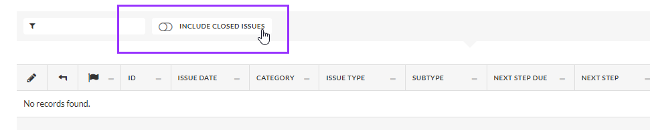
Use the Include Closed Issues toggle!

CSIs with a Performance/Package
An Exchange -> Performance Change CSI should always have the performance they're coming out of
A Hold Seats Until → Exchange Request CSI should always have the performance we're holding seats for
Due to a known defect, searching for a performance/package to add to a CSI and just selecting the season it belongs to only returns 10 (max) results. To find the correct performance make sure you use a keyword from the title.
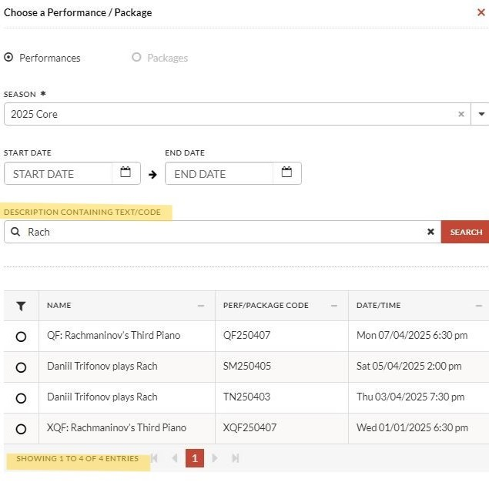

Calendly
What is Calendly?
Calendly is the service we use to book outbound customer calls.
This is used during subscription for Outbound Renewal plans, but also for customer follow-up throughout the year when we need to ensure someone is called back at an agreed time.
You can complete the Calendly booking request on behalf of a customer or send the link to the customer for them to book.
Calendly Phone Booking Request

First Nations Feedback Response
To equip Box Office attendants with responses to feedback regarding MSO Voice to Parliament support, First Nations programming, Acknowledgement of Country and NAIDOC week celebrations.
First Nations Feedback Response
Managing Difficult Customer Calls
CSI Formatting Rules (Access CSIs)
Access CSIs are formatted differently to normal CSIs - they have 1 additional line at the start that goes to ACM. The Front of House team needs to be able to quickly identify the seats and action required.
You'll also regularly use the below terms for wheelchair seats:
SEAT OUT - means the customer is attending in a wheelchair and ACM need to take the seat out
SEAT IN - means customer with limited mobility is attending, but ACM needs to leave the seat in
ACM FOH has requested that format as follows:
“SEATS, ACTION – Details”
They need the Access CSI to start:
- Short and Concise
- All on one line
- No Context, just core details
i.e - Circle H17-18, SEAT IN - Customer attending on crutches + no stairs
and underneath, we do a regular CSI, formatted as follows:
“Date, Initials
Order Number
Summary
---------
Email 1
---------
Email 2”
An example of Access CSI can be found below:
SEAT LOCATION ACTION
Stalls A60-61, SEAT OUT - Customer attending in Wheelchair
Date, Initials 12/05/24, KC
Order Number Order 12345
Summary Customer John has Parkinson's and will be attending in a wheelchair
--------- ---------
Email 1 Hi, you indicated you had access needs for this event...
--------- ---------
Email 2 Hi, yes my recent diagnosis means I'll be attending in a wheelchair....

CSI Formatting Rules (Regular CSIs)
When writing CSI's, it's important to follow specific formatting rules in order to include important information and make it easy for the next reader to understand.
For Regular CSI's, please format as:
Date, Initials
Order Number
Summary
---------
Email 1
---------
Email 2
An example can be found below:
Date, Initials 12/05/24, JB
Order Number Order 12345
Summary: Customer left their hat at Jams 07/05 after 11am session...
--------- ---------
Email 1 Hi Box Office, I think I lost my hat on the weekend…
--------- ---------
Email 2 Hi Geoff, your hat was not handed in to lost property…
If you need to update an existing CSI, please format as:
Date, Initials 12/05/24, JB
Order Number Order 12345
Summary Customer left their hat at Jams 07/05 after 11am session...
Summary Update UPDATE:
13/05 AB - They emailed back saying the hat was in the car...
--------- ---------
Email 1 Hi Box Office, I think I lost my hat on the weekend…
--------- ---------
Email 2 Hi Geoff, your hat was not handed in to lost property…
--------- ---------
Email 3 Hi Box Office, I’m so sorry! It was in the car all along...
SCRIPTS TO END CALLS
Some phrases to assist you end calls with customers, if they are happy to continue chatting after enquiry is complete or when they are indecisive/unprepared or when it is better to move to a follow up email:
Move the call to follow up:
Useful for lengthy enquiries about different subscription series, general indecisiveness on concerts to attend and possibly how to exchange an options etc.
"I'm glad we could talk today! To make sure I have all the information, I'll send you an email with a summary and the next steps for you. Thank you again for your time, and have a good afternoon/evening/weekend" → Email the summarized information and specific next steps as needed
"I really appreciate you sharing all of that, and I think we've covered/have all the details we need to for now. And will send an email with a summary and the next steps for you. Thank you again for your time, and have a good afternoon/evening/weekend" → Email the summarized information and specific next steps as needed
"Is there anything else I can help you with before we finish?"

Advise of time constraints:
Useful for getting off a call with a very chatty person, when the initial request has been completed etc
"I really appreciate you sharing all of that. I have to take care of other customers waiting now, but it’s been great helping you today."
"Thank you so much for your time today. As I don't want to keep our other MSO customers waiting any longer, was there anything else I can help you with before I go??"
*Good for "urgent enquiries" - bring it back to the upcoming/current week concert they are looking at.
"Before we finish, let me just double-check: Was there anything else that you needed help with for the concert this week/your tickets for the xxxx concert?" → Send email follow up with specifics if required.

If something more final and direct is needed
"Thank you for calling today. we have everything we need to... (complete order/exchange etc), and I'll be sending you a confirmation email shortly also. Have a good afternoon/evening" → Send email with final details as needed
"I’m afraid we’re running out of time, but feel free to email the Box Office if you have any further questions or enquiries"
"So sorry, but I will need to go now. But thank you for your time and the lovely chat. We look forward to seeing you in the concert halls/next concert"

Subs renewal - Unprepared caller
"I know your Subscription is important to you, and I want to make sure I’ve got all the details right. I’m going to send over an email summary with everything we’ve discussed, and when you are ready, we can schedule a call and help to finalise it for you" → Include Calendly link

Access Bookings
Assisting with accessible bookings is a crucial part of the Box Office's role.
- Types of Access Requirements
- Information Required for Access Bookings
- Seating Access Bookings
- Recording Access Requirements - Access CSIs
- Access CSI Lifecycle
Please check the individual venue in the Venue Information Section for detailed access information.

Feedback and Complaints
Recording feedback is an important part of maintaining supportive and rigorous policies and procedures. Whether good or bad, all feedback should be CSI'd. These CSI's are passed on to the relevant departments, as per the CSI pathways.
Record feedback using the CSI path:
Contact Method > Issue Type (Positive/Negative Feedback) > Relevant DepartmentIf the feedback doesn't require follow up, we can then close the CSI.
Negative Feedback and Complaints:
Phone:
- We use the LEAP model for difficult customer calls. If a call is particularly difficult, you can always tell the customer you'll take some time to problem solve with your supervisor, and call them back.
Email:
- If the feedback is general in nature, or doesn't require follow up, we can thank the customer for their feedback and CSI the email per above pathway. If the feedback requires follow up and needs to be escalated, we can thank the customer and state we will respond to their feedback, CSI the email, place email in sups folder, and let a Sup or TL know. An email template for both options is available below in the comments.

Positive Feedback:
- For both phone and email, we can thank the customer and CSI the interaction. It's important to CSI positive feedback - particularly if it's regarding your customer service!

Difficult Customers - Calls & In Person
Nobody should feel unsafe in any situation at work. The below procedures apply if this is experienced in these capacities.
Abusive language is not tolerated. Attendants should feel empowered to put themselves first by ending calls, taking breaks, stepping away.
LEAPS Customer Call Poster

Web Login (inc. Issues/Troubleshooting)
Includes updating a email/Login and Troubleshooting below.
Update Email Address and Web Login
- Find the correct Constituent account
- Go to Email in constituent menu
- Select Add New Email on top right
- Email Type: Email Address (most common)
- Toggle Primary
- Email Address: enter new email
- Save & Close
- Go to Logins in constituent menu
- Select Add new Login in top right
- Login Type: Default TR_LOGIN_TYPE
- Toggle Primary
- Username: Enter new email address
- Associated Email address: select matching email from dropdown
- Save & Close
- Go to Email in constituent menu
- Edit existing old email address
- Toggle Primary off
- Select Inactive in top right
- Check selected purposes associated with that email
- Save & Close
- Add appropriate purposes to new email address

Issues Updating Customer Login
If a customer has a duplicate account and they both link to the same email/login this can prevent you from adding that email to a new login.
- Inactive any previous logins linked to that email as per above
- Add New Login as per above
- If stuck ask a TL!
Resetting Password
- Go to Logins in constituent menu
- Edit Primary Login
- Select "Send Email Token" button
- This pushes a "Forgot Password" email to that email address and allows customer to establish a new password
- Link is valid for 15 mins

PROCEDURES

Donating Tickets
Due to a Tessitura defect, if someone would like to donate their tickets back to MSO they must be processed a specific way.
- Tickets can returned in either the original order or a new exchange order.
- Funds from the tickets placed on account
- New order created and donation membership added
- Pay off the order with funds on account.

Geelong Subscriber Forms
Geelong Subscription Forms

Merch Orders
Processing In Person Merch Orders
*Please note merch orders often automatically add a $10 postage fee to the order. Please make sure this fee is removed for in person purchases.
When a customer wishes to purchase merch in person, we can add the merch to the order via the Product Catalogue or QuickSale sections. Depending on how busy the venue shift is for an in person order, it can be processed with the Walk Up constituency (#182315).
When adding via Product Catalogue, you can select the merch as you would a performance. Merch can be found at the end of the year, as seen here:
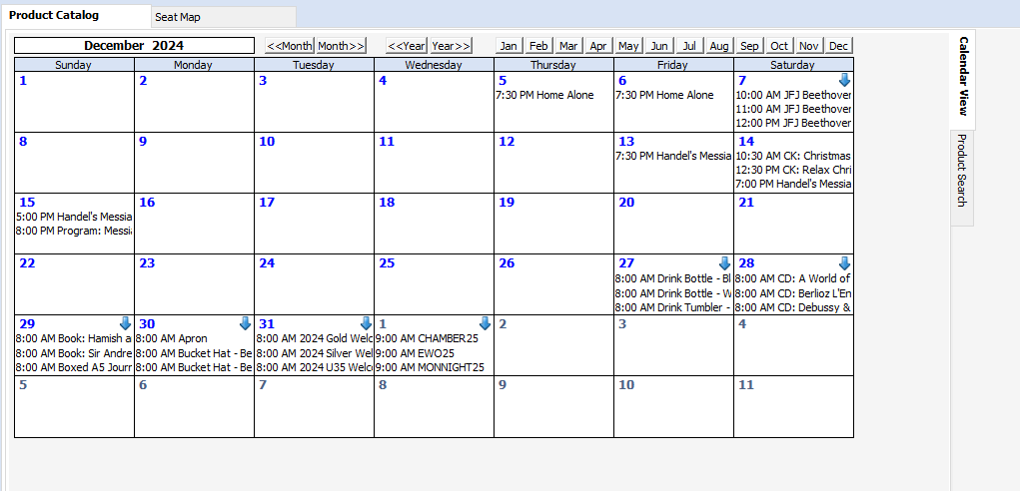
The easier way to do this is via QuickSale, which is to the right of the Product Catalogue and Seat Map when you're in an order. You can then select either the Merchandise > Jams for Juniors, or just Merchandise, depending on what you need to find:
You can then select the kind of merchandise the customer would like to buy. For example, here I'll select a Picnic Rug. At the bottom left you can select the price type needed (full price, subscriber discount, etc). To the bottom right you can then choose to either add to cart (if you're adding more than one item) or add to cart and pay. I've highlighter the options here:
QuickSale often adds the postage fee to merch items, so at this point it's good to check the order total on the right and override the fee if need be. You can then select the appropriate payment method!

Return to Sender
Occasionally posted mail is returned to us, in which case we need to be in touch with the customer to confirm their postal address.
When processing RTS mail, we need to:
- Call the customer and ask if they would like to confirm or provide a new email address.
- If so, we'll update their address in Tessi by clicking addresses > adding details of new address > toggling 'primary' when adding the address > clicking save and close in the bottom right.
- We'll then make the old address inactive by click on the original address > clicking 'inactive' in the top right, clicking 'save and close' in the bottom right.
If we can't get in touch via phone, or the customer doesn't wish to provide a new postal address, we need to:
- Email the customer the RTS email below, if they couldn't be reached by phone
- Add 'Return to Sender' attribute in Attributes
- Add CSI detailing email/phone call details, and what material has been RTS (tickets, marketing material etc)

Instructions for Mail Merge/Brochure Request
See ✓ Brochure Requests Report task in Daily Workspace and consult a TL.
Download the Brochure Request - Season 202X.csv file that has come through to the Box Office inbox. Usually generates in the early hours of Wednesday Morning.
Download it somewhere you'll find it (i.e desktop)
Open the S26_Mail Merge Brochure Letterhead.dotx - needs to be open in the App to perform the mail merge
- You have to Open in Desktop App
- Go to Mailings → Start Mail Merge → Step-by-step Mail Merge Wizard
- Step 1: Select Document Type: Letters
- Step 2: Select starting document: Use current document
- Step 3: Select Recipients: Use an Existing List → Browse
- Select the CSV file you downloaded
- Preview Results - << >> Click through and adjust as necessary
- Finish and Merge
- The last page is always blank
- Set Pages 1 to (Total minus 1)
- ie. If there are 10 pages select Pages 1 - 9 (because page 10 will be blank)
- Print to C60 Marketing Printer
When packing the Sub Brochures:
Print new 2026 Subscriber forms Subscriber Booking Form + CYO Form Combined - Print Friendly.pdf
- Print on Both Sides - Flip on the Long Edge
Merchandise Stock Take
Merchandise stock is regularly counted, particularly before and after concerts where we sell various products at our BO counter.
This stocktake list is found in this SharePoint folder, by clicking on the Sales folder and then to Merchandise and in the relevant year.

Deceased Constituents
We may be notified through a number of channels that a constituents is deceased. Please choose the appropriate situation:
Deceased Constituent – No outstanding orders/tickets on account
Deceased Constituent – Outstanding orders/tickets on account

Deceased Estate Policy
SCOPE:
The scope of this policy is to establish a clear and efficient process for handling outstanding monies with the MSO when the customer is deceased. The policy aims to provide best practice advice to ensure that the assets of the deceased's estate are appropriately managed and disbursed to authorised representatives.
POLICY:
- The MSO shall require a valid Grant of Representation as proof of authority for anyone contacting the organization on behalf of the deceased customer's estate. The Grant of Representation may come in various forms, including Rebate, Letters of Administration with the Will annexed, Letters of Administration, and Limited Grants.
- In cases where the refund is to be paid to a Trust account, the MSO shall require appropriate documentation to confirm the validity of the Trust and the authority of the representative to act on behalf of the Trust.
- The MSO shall maintain open and transparent communication with the authorised representatives of the deceased customer's estate.
- The MSO shall maintain accurate and comprehensive records of all communications and transactions related to deceased customers' outstanding monies.
- These records should include details of the Grant of Representation, Trust account documentation (if applicable), verification process, and any other relevant information.
- The MSO staff involved in handling cases related to deceased customers should be trained to approach these matters with sensitivity and empathy.
- The MSO shall ensure that all aspects of this policy comply with relevant legal and regulatory requirements related to deceased customers' estates and assets.

Accessibility Special Requests email report
Accessibility Special Requests report comes through from ramp@krios.com email daily.
This report lists all customers who've purchased online and ticked the 'I have access requirements' box on the website.
We work down the list, assess each order, and contact each customer to verify their access needs (and modify if necessary).
Once we've addressed an access need, we can remove the 'Spec Req' tag from their order.
Ctrl+C Copy the order number and use the Delete Special Request Report in Tessitura to delete the request from the order (see image below).
(Probably best to star the report, as you'll be using it often)
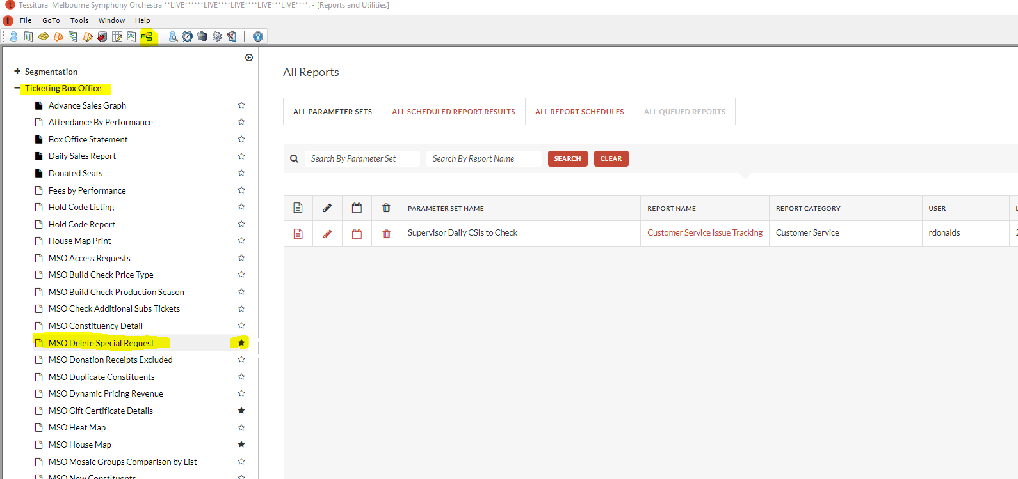

HowScan Procedure
HowScan is an app used to scan tickets during Iwaki based performances, where there is not a separate Box Office ticketing the event. There are two mobile phones (Google Pixels) included in the briefcase, which has the HowScan app downloaded.
The full HowScan scanning procedure is available here.
Please be sure to remember to move between performances when ticketing for multiple events on the same day, such as Jams for Juniors.
Please note that there is a current known issue where HowScan will scan e-tickets, either printed or on the phone, but will not scan tickets printed by the boca. For this reason, it's good to also have a seating book printed on hand.

School Bookings procedure
Due to confusion with payment deadlines for schools attending multiple performances in previous years, school bookings will now be 1 order per concert date. This means that there may be multiple rows in the tracker for a booking request if the school is booking for multiple performances.
Procedure will also vary depending on the type of school booking/performance

School Bookings Tracker
This spreadsheet is shared with TLs to track the subsidy program.
- Teachers are highly encouraged to make school booking requests via booking request form to ensure accurate and correct school and teacher information.
- If teachers are unable to submit a request via form for any reason (e.g. web issues), you may process the booking over the phone/email; however, please add the request and all relevant info to the tracker
- Marta will extract the data from the website back-end and enter into the tracker every Monday.

School Booking Request Form

Geelong School Booking Request Form

School Excursion Documents
Send both MSO and venue documents. Please make sure you send the file itself and not the link to the SharePoint.

Batch Printing Tickets
Batch printing for postage is done daily - check Asana Task List.
Batch printing for Venue Collect will be done before consignment - either 3pm day of concert, or 3pm of last business day before concert for weekend events.

Batch Print for Postage
IMPORTANT: Select the printer you wish to print as your default printer under Preferences. Otherwise, you will need to select the printer for each order.
- In the order window, click the ‘Order #’ chiclet to open the order search window
- Search by performance date, search from ten days after the current date until the end of the current year.
- The filters that should be applied are:
- Delivery: Standard Post
- Paid: Yes
- Seated: Yes
- Printed: No
- Select ‘search’ in the bottom right-hand corner.
- Click ‘Owner Name’ to sort orders into alphabetical order.
- Check the order notes for any notes that say ‘do not print’ or “print with [another order]” and remove those.
- Select all orders and press print.

IMPORTANT: To the right of the Print button at the bottom of the screen, select ‘Continuous’. Otherwise, you will have to manually start each order.

Venue Collection
IMPORTANT: Select the printer you wish to print as your default printer under Preferences. Otherwise, you will need to select the printer for each order.
- In the order window, click the ‘Order #’ chiclet to open the order search window
- Search by ‘Product’. Select the ‘season’ (for example, 2020 Core, 2020 Special etc) and then the ‘Perf Code’. Double check that the perf code includes the correct Date and Time of the performance you would like to print for.
- Filter tickets by
- Delivery method: select Collect @ Venue, MUSO/Student Collection
- Paid: Yes
- Seat: Yes
- Printed: No
- Click ‘Search’ on the bottom right-hand corner.
- Click on ‘order notes’ to sort orders and bring anything with a note to the top. Highlight and ‘remove’ (bottom right-hand corner) anything with notes that looks like it may need further investigation.
- Click on ‘Perf date’ to sort subscriptions to the top. These should have a blank perf date column. Remove these to be printed after the main print.
- Click ‘Owner Name’ to sort orders into alphabetical order.

IMPORTANT: Steps 8, 9, and 10 are VERY IMPORTANT and will save you from printing each order individually

Relocates Process
Relocations
In some instances, due to operational requirements, we can be required to relocate customers. Common relocates include:
- Balcony Relocation
- Choir Stalls Relocation
- Cancelled Concert Relocations
For All Relocates:
- Do not remove original seats until relocate is confirmed
- Check for Plan on Customer account
- Update plan if necessary
- Check for Relocation CSI/Create Relocation CSI

Releasing Subscription
Once our Subscription period is over, we'll release any outstanding held subscriptions. These will usually be sent through as a plan in your portfolio in Tessitura. If you're unsure whether a subscription should be released, please ask for a TL or SUP To release the subscription, we'll:
- Open the subscription order
- Select all performances in sub line items
- Select 'delete' in the bottom of the order
- Note 'released sub' in the order notes
- CSI that the sub was released

Open CSI Report
We receive a daily Open CSI Report email in the inbox from 'tessitura reports'.
This email will contain an excel spreadsheet with customers' data, including their name, customer number, and details of any open CSI's we have in Tessitura on the date the report was pulled.
To process this report, we'll open the customers profile in Tessitura and read the CSI to determine if it can be closed.
- Some CSI's should remain open. An example of this is a Handle With Care CSI.
- Some CSI's will require follow up work, Where applicable, we can do this now and update the CSI.
- Some CSI's we can immediately close. An example of this is when an exchange has been processed, but the CSI hasn't been closed.
Access Report
We receive a daily Accessibility Special Requests email in the inbox from 'tessitura reports'.
This email will contain an excel spreadsheet with performance and customer details. These customers have checked a box when purchasing online that 'one or more attendees have accessibility requirements'.
To process this report, we'll email the below access email to the customer and CSI.
- If the customer replies with access needs, we can check that their current seats are suitable. If not, we can offer them a free seat change for their party. We'll then write an Access CSI. If the customer or guest is in a wheelchair, please be sure to note if they're remaining in the wheelchair or transferring to a seat, and place this in the Access CSI, as we'll need to communicate this to the venue. This ensures we have the wheelchair seat in or out as needed.
- If the customer replies that they ticked the box by accident, no problem! We'll update and close the CSI.

Manually Processing Instalment Payments
- Go to the "Constituent Search" and find customer account
- Go to "Constituents" from top menu bar and select "View Invoices" to open outstanding invoices window
- Tick "Pay" box next to outstanding invoice line item
- Click "Payments" down bottom of window
- This will open Moneybags window and you can manually add amount to be paid and add in payment method.

Hold Until Report
We receive a daily Hold Until Report email in the inbox from 'tessitura reports'.
This email will contain an excel spreadsheet with customers data, from customers who currently have orders unpaid and 'on hold' with us. Customers should have a confirmed date in the CSI, after which we specify that we'll release these seats back to general sale.
To process this report, we'll open the customers profile in Tessitura, and read the CSI to determine the date we confirmed the customer needed to be in contact by.
- If the date is a few days to come, we can leave as is.
- If the date is today, we'll call and/or email the customer to remind them that we'll release the order at 5pm. We'll CSI, but leave the order as is until after 5pm.
- If the date has passed, we'll release the order and update the CSI.

POLICIES

Instalment Plan Grace Period - Purchasing in July
If purchased in July,
Payments aren't being deducted until September
They must pay the $10 instalment plan fee during the transaction.
  - First payment will be deducted overnight
  - Second payment will be deducted 6th September
  - Third payment will be deducted 4th October
  - Fourth payment will be deducted 1st November

Concessions
What constitutes an eligible concession with the MSO differs depending on the venue, performance, and kind of concession held:
- Australian Commonwealth-issued concession cards are means-tested concession cards, and include the Healthcare Card and Pension Card. We offer a concession price for all venues and performances.
- Companion Cards are a type of concession for people with disability, allowing them to bring a companion to assist them in attending the performance. This concession must be accompanied by a paid ticket. We offer a complimentary ticket under pricetype 'C Card' for all venues and performances.
- Seniors Cards are a non-means tested concession and refer to state issued seniors card. We offer a concession price for Melbourne Town Hall performances and Chamber series performances only.
- Student and Child Price concessions are a different form of concession, relevant to students with a student membership, and children and young adults under 18 respectively. More information can be found at the relevant manual sections. If student price and/or child price tickets aren't available, they are eligible for the concession price.
Concession Card details must be placed on file with us prior to ticket purchase. We typically add concession details as an attribute, including type of concession, concession number, and expiry, where relevant. Once a concession has been added on file, we won't need to ask for it again until it expires.

Group Bookings
For group bookings of 10+ people, we offer a group booking discount of 15%.
Group discounts are available for both subscription series and single ticket purchases. For subscriptions, you will pay one reserve lower than your ticket.
We typically recommend organisers of group bookings email in with their details, so we can build the order without keeping them on the phone. For group bookings, we can hold the order while the organiser confirms numbers and payment.

The digital and mobile ticket delivery methods are not available group tickets. The collect at venue fee is waived for these tickets.
- Group Tickets 10+: Physical tickets only (collect at venue, postage). Collect at Venue fees are waived
- This is to reduce congestion at auditorium doors as the group is entering, and to ensure all tickets are scanned and no seat confusion.
- The PAH and mobile ticket options will be hidden at the checkout if the order only has these price types.
- If digital delivery methods are selected at checkout, it will be changed to venue collect, and a message will appear at the cart informing them of this.
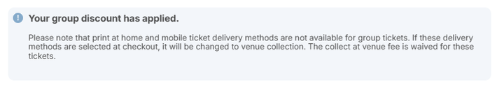

Phone safety protocol
Should we end up in a situation where multiple aggressive / unsafe calls are being received, the following protocol will be enacted:
- Phones will be turned off and calls will be call back only
- The voicemails will be reviewed and triaged by Supervisor/Manager/HoD/DoD
- All information to be logged in Tessi (where possible)
- Social media and email responses will be monitored before phones are reopened
This procedure would be enacted from a recommendation as per the below:
- On reports of aggressive calls by attendant or TL, TL/Supervisor/Manager will notify their manager
- They are to notify either Director of Department or COO or CFO for approval to close. Information to be provided:
- Number of calls
- Nature of complaints
- Action taken depending on outcome of above

High risk situations
In the case where high-risk box-office situations are encountered, the following steps are to be taken:
- Team to be updated as per their nominated preferred method
- At time of writing, survey results to be gathered, so updates will go to personal BO emails (to those rostered on on the affected day(s))
- Manager to brief Team Leader who is next rostered on
- Manager and Team Leaders to brief attendants and remind them of Difficult Customer (Calls) and Phone Safety protocols
- Empower attendants to end calls if needed and stay off phones
- Safety and wellbeing reminder to be provided
- Taking breaks - as much as required
- Updates to be provided as received, including the steps moving forward
- Refer to Difficult Customers notes below

Difficult Customers - Calls & In Person

EMAIL TEMPLATES
[SKIPPED PASTING AS ALL OUT OF DATE, USE ONES FROM INBOX]

OTHER

Digital Tickets
Digital Tickets:
- Digital tickets are issued 48 hours prior to each performance, making them easier to access and manage before the events.
- If you cannot locate your digital tickets you can contact the Box Office via phone or email to request the tickets be reissued or approach the Box Office in person from up to 90 minutes before the event.
- Group tickets cannot be issued as digital tickets.
- There are two types of digital tickets:
- PDF tickets: PDF tickets are sent as as a PDF attachment via email and can be presented on your phone for entry to events. This delivery method is free.
- Mobile tickets: Mobile tickets embed the ticket in an email and can be downloaded and stored in your ticket wallet. This delivery method is free.

Tickets as gifts
If someone is purchasing tickets as a gift and needs them RIGHT NOW, use the Gift/Partnerships MOS

Tessi VS16
Wordfly Custom Screen Delay
There is a 3-7 second delay loading anything in the Wordfly custom screen, including clicking between pages/viewing emails etc.
Searching Customers by Phone Number
Begin the search with a #
Tessitura Version 16 Help System
https://www.tessituranetwork.com/Help_System_v160/Landing.htm
V16 Header Icons
Old Icon | New V6 Icon
Open CSIs
Concession Card Holder | 
Access: Wheelchair user | 
Return to Sender | 
Student Member: no previous icon | 
ACM Import Order: customer has an imported ACM order with a performance with a performance within the next month or the previous month
A reference of what the icons in V16 relate to. The old icons still appear on the order window and as such will be updated to match the new icons moving forward.

Tessitura Version 16 Reference Videos
Tessitura Version 16 Reference Videos, courtesy of Sarah and Michelle
- Creating a New Constituent in Version 16
- Purchasing a FOTMSO Membership
- Setting up a Single Ticket Order

- Navigating Constituent User Interface: Part 1 Creating a Favorites List
- Navigating Constituent User Interface: Part 2 Relationships and Attributes
- Navigating Constituent User Interface: Part 3 Orders and Tickets
Tessitura Web Login Page
Tessitura Web Log-in: https://melso0auvicwebprod.tnhs.cloud/tessitura/Login
Username: tnhs\citrix username (e.g scamm377)
Password: Citrix password
**You will need to sync an authenticator app (e.g Google Authenticator) with the QR code for your log in.

IDEAS / THINGS TO ADD
Update wording around Hearing devices and T-coil/ Telecoil at Plenary
Hi XX,
We are writing to you regarding your tickets to Man From Snowy River in concert, Sat 3/8/24, 7.30pm.

You are receiving this email as when purchasing tickets, you indicated that someone attending may need the hearing loop. We're just getting in touch to see whether there’s anything we can do to ensure that you have an easy and enjoyable experience with us.
I can confirm that all the seats in The Plenary (the concert venue) is able to access the hearing loop. If you already have a Telecoil (T-coil) hearing aid, then you should be able to tune into the hearing loop yourself. Alternatively, if you would like to borrow a closed loop hearing assistance device, neck loops and portable receivers are available for loan (free of charge), from MCEC Concierge desks on the ground floor. If you wish to loan a device, on the day of the concert please let the MCEC staff know at the concierge desk on the ground floor.
If you would like to go over any further details, please don’t hesitate to reach out via phone on (03) 9929 9600 between 10am – 5pm on weekdays. Alternatively, you can reply to this email, and we'll do whatever we can to accommodate your needs.

Kind regards

Household Operations
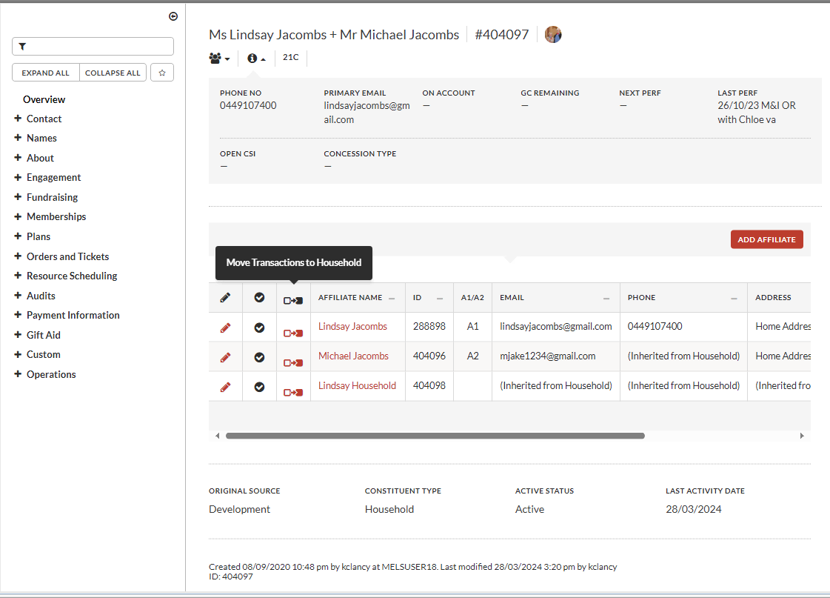
To include - > The groovy function to move Transaction to Househould
(It's different in Version 16 - see above image)

Make notes on using Box Office (+) holds
Stop using them!!!
When you put a hold on a seat, it stops customers buying them on the website.
We’ve been put (+) holds in and forgetting to remove them – BAD!
This is an incorrect way to hold seats – use an Unpaid order and a Hold Until CSI
The only scenario where we should be putting seats on (+) holds is when the seats are stuck in a customer's cart on the website and there's a reasonable chance they'll get nabbed in the next 10 minutes. You should be staying on the call with the customer while you're using the hold and releasing as you place the seats.
EVEN THEN, we have to release the holds once the transaction is finalised

Add image examples to Regular CSIs, Access CSIs, Exchanges and Credit Requests
Use slides from the Subs Training 2025 powerpoint
Update the images in the following Tasks in the Asana manual:
CSI Formatting Rules (Regular CSIs)
CSI Formatting Rules (Access CSIs)
General Venue Exchanges
Credit Requests / Medical Certificate
Add Carer Card details to the Concessions section

Refresher Training
W1 – Exchanges

EXCHANGES:
- Exchanges can be initiated up to 3 hours before the concert starts, and must be complete in 3 business days → This should be included in communications to customers - email/verbal + CSI
- Most Exchanges has a Fee involved → please make sure you know the types of customer that have fee-free exchanges.
- Patron (PAT)
- MSO Guardian
- Subscribers (26S or 26C)
- FOTMSO Gold members (MF1)
- Student members (S26)
- Anyone with Staff price* tickets.
- For non-subscribers wanting to exchange Classic Kids, Jams for Juniors and Open Rehearsal performances, only a single exchange fee applies rather than per person.
- All steps should be noted in a CSI, so other team members can follow and action to finalize exchanges if needed.

THINGS TO REMEMBER:
- Exchanges must be done in a new order; this helps both us and the customer keep track of correct concerts.
- Always use Source - 477 (Exchange)
- Exchange orders need to be made in either Exchange SUB or Exchange NON SUB Mode of Sale (MOS)
- The NEW concert should be selected first ~ and then return the tickets to the one they cannot attend.
- ALWAYS - Clarify and Confirm how many tickets they were exchanging, and specific seats if known for those with multiple tickets.
- Don't forget to CSI the exchange details!!
- DO NOT return the tickets of the concert they cannot attend, until you have customer confirmation/approval to finalize the exchange.
BOX OFFICE MANUAL LINKS:
- General Venue Exchanges
- Exchange Ticket Price Explainer

W1 - Hold Codes

Different Types of Hold Codes, what they mean, and can they be used??
THINGS TO REMEMBER:
- When looking for seats for a Patron or long-time Subscriber, and selection in circle or stalls is limited due to Holds placed on seats - please check with Marta, if you can use any of the Holds that are part of the MSO allocation for internal VIP's - and appropriate seats will be found for your customer.
- Access Holds for Wheelchair spaces - if our allocation of access seats have been used, ask Marta about those that have been consigned to sell through ACM, and these will be requested from them - can take a little time, so if the customer is on the phone - we will absolutely assist, but will need to call them back, when the order is all set up.
- If the seat is Blue on Tessi, always check the HOLDS tab to see the detail on the hold.

HOLD CODES - TYPES/MEANING:
